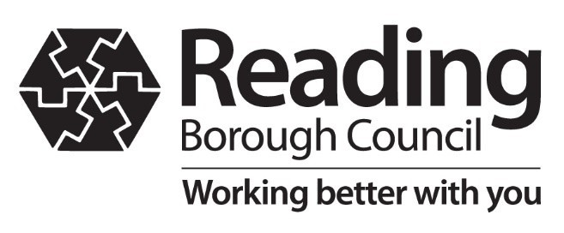 | Meradin Peachey  Director of Public Health, Berkshire West  Civic Offices, Reading RG1 2LU  CVNotifications@Reading.gov.uk  Our Ref: CV-19 extra testing  7 June 2021

AN URGENT MESSAGE FROM MERADIN PEACHEY, DIRECTOR OF PUBLIC HEALTH:
Please take an extra Covid-19 test to help suppress the spread of the virus in your area

Dear Resident

I am writing to urge you to take part in a programme of extra ‘surge’ testing for Covid-19 cases run by Reading Borough Council and NHS Test and Trace in your area.

Covid-19 case numbers are rising fast in Reading. There are nearly 100 cases per 100,000 people in Reading; 37% of cases are the new ‘Delta’ variant first identified in India, which is more easily spread from person to person. Hospital admissions are increasing, although they remain lower than previous periods, and we are once again climbing towards the levels of infection we had in second lockdown last autumn.

We are therefore urging everyone over the age of 12 who lives, works or studies in postcode areas RG1 3**, RG1 5**, RG1 6**, or RG1 7** to take an extra PCR test between Monday 7 June and Sunday 20 June.

It's vital that people come forward for the test so we can find and isolate as many cases as possible, and therefore suppress transmission of the variant in Reading. You should get tested even if you don’t have symptoms, even if you have had the vaccine and even if you have been taking regular lateral flow tests (LFTs) or ‘rapid tests’.

Getting tested

You can get a test by coming to a test site, you do not need an appointment:
- Reading Town Hall, Blagrave Street RG1 1QH, open 07:00-20:00 Monday-Friday and 12:00-20:00 on Saturdays, walk-up.
- Prospect Park, Liebenrood Road RG30 2ND, open 14.00-20.00 Monday-Sunday, walk-up.
- Reading University, London Road RG1 5AQ, open 14.00-20.00 Monday-Sunday, walk-up.
- Reading University Car Park 7, Reading University RG6 6DR, open 12.00-18.00 Monday-Sunday, drive or walk-up.
More test sites and opening hours are on our website www.reading.gov.uk/testnow

You can also order a test online at www.gov.uk/get-coronavirus-test or by calling 119.

After your test

If you test positive, you must self-isolate immediately along with your household. You should engage with NHS contact tracers when they call. Contact tracers will never ask you for money or bank details. You can find out if you are eligible for a self-isolation support payment or get help to self-isolate via the One Reading Community Hub. For details go to www.reading.gov.uk/coronavirus-covid-19

The more cases of the variant we find, the better chance we have at suppressing it. Please do the right thing for Reading and get tested to protect you and your loved ones.
For more information visit www.reading.gov.uk/testnow

Yours sincerely

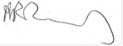
Meradin Peachey
Director of Public Health for Berkshire West

If you need a translation of this information please email cv19notifications@reading.gov.uk

যদি এই তথ্যের অনুবাদ আপনার প্রয়োজন হয়, তাহলে অনুগ্রহ করে cv19notifications@reading.gov.uk

यस जानकारीको अनुवाद आवस्यक भएमा कृपया इमेल cv19notifications@reading.gov.uk

ਜੇ ਤੁਹਾਨੂੰ ਇਸ ਜਾਣਕਾਰੀ ਦੇ ਅਨੁਵਾਦ ਦੀ ਲੋੜ ਹੈ ਤਾਂ ਕਿਰਪਾ ਕਰਕੇ cv19notifications@reading.gov.uk

گر آپ کو اس معلومات کا ترجمہ درکار ہے تو براہ کرم ای میل کریں cv19notifications@reading.gov.uk

Jeżeli potrzebne jest tłumaczenie tej informacji, należy wysłać wiadomość e-mail na adres cv19notifications@reading.gov.uk

यदि आपको इस सूचना का अनुवाद चाहिए है तो कृपया cv19notifications@reading.gov.uk

