summary proof of evidence (ecology)

on behalf of reading borough council:

55 VASTERN ROAD, READING
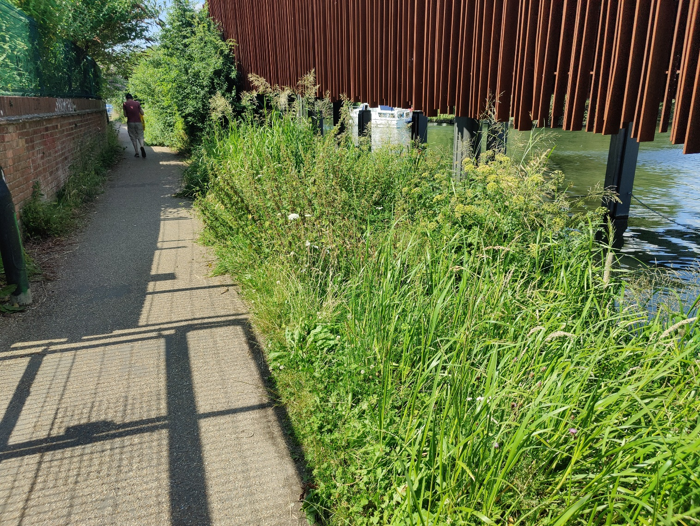

Planning inspectorate case ref: APP/E0345/W/21/3276463
Reading Borough Council Ref: 200188
Report Date: 29 September 2021
Authored By: Giles Sutton BSc (Hons) MSc CEnv MCIEEM
Tel: 01189 759387
Email: giles@gsecology.co.uk

Author’s details
    - My name is Giles Sutton. I am a member of the Chartered Institute of Ecology and Environmental Management (CIEEM) and a Chartered Environmentalist. I hold a Bachelor of Science (Hons) in Agriculture and Environmental Science from the University of Newcastle upon Tyne and a Master of Science in Ecological Management from Imperial College London.
    - I am the owner and director of GS Ecology Ltd. I advise planning authorities, developers, and others on the ecological implications of planning applications and land use change.
    - I have more than 20 years’ experience working as a professional ecologist. I have advised Reading Borough Council on ecology related matters since 2008.
    - I know the appeal site and have viewed it from public footpaths and roads. I know Christchurch Meadow well.

Background
    - There were 7 reasons for refusal (RFR), one of which, RFR 3, is directly related to ecology. This reads:
“3. By virtue of its height, massing and proximity to the river, the development will shade the River Thames and impact on its marginal habitats with a lack of appropriate mitigation being demonstrated. There would also not be sufficient space within the riverside buffer for a sustainable long-term relationship between the riverside buildings and the required large canopy trees. The proposed development is therefore contrary to Policy EN11 in particular, and also Policies EN12, EN13, EN14, CC7, CR2, CR3, CR4 and CR11 of the Reading Borough Local Plan (2019), paragraph 175 of the National Planning Policy Framework (2019) and objectives of the adopted Reading Borough Council Tree Strategy (2021) and Reading Biodiversity Action Plan (2021).”
    - My Proof of Evidence (PoE) summarised here focuses on the element in bold above relating primarily to the River Thames and its marginal habitats. The remaining element of the reason for refusal is separately discussed within evidence provided by Sarah Hanson, the council’s Natural Environment Officer.
    - The council’s case is as follows:
- The ecological value of the marginal habitat (that will be affected by the development) is greater than the appellant states.
- The proposals will harm the river Thames and its marginal vegetation
- There is a scheme that will have less harm
- That the appellant’s offsite compensation (even if it were to be otherwise acceptable) is very unlikely to be sustained in the long term.

Planning policy and documents
    - Relevant planning policy and documents includes paragraphs 8, 174, 179, 180 of the NPPF, EN11, 12, EN13, CR4, CC7, CR2, CR3, The Reading BAP and the Reading Tree Strategy

The ecological value of the marginal habitat (that will be affected by the development) is greater than the appellant states.
    - The River Thames, including its marginal habitats is a “priority Habitat” as defined in the NPPF. It is Reading’ most important wildlife corridor and is designated as a green link on Reading’s proposals map. It is a core element of Reading’s green network as defined in policy EN12.
    - The appeal site is directly adjacent to the river. At this location there is a 100m strip of marginal vegetation (marginal vegetation refers to plants growing along the base of the bank with roots in the water and provides valuable habitat for wildlife) that was planted in the river when the new footbridge was built. It was planted using coir rolls. There is galvanised wire mesh to protect it on the northern side.
    - There has been debate about the dimensions of the marginal vegetation adjacent to the appeal site. The measurements, using a tape measure, show that the marginal vegetation directly adjacent to the appeal site is 53.9m in length (shaded by the development) whilst that to the southeast measures 45.8m (not shaded by the development).
    - The width of the vegetation, i.e., between the concrete bank of the river and the wire mesh that contains the vegetation is 60cm adjacent to the development site.
    - Other than two short sections there are no other areas of this marginal habitat along either side of the River Thames at Christchurch Meadow or the Thames Promenade. The closest such habitat is approximately 500m to the east on View Island and beyond Thames Side Promenade 2km to the west.
    - The appellant’s ecological consultant asserts that the marginal habitat is of “neighbourhood significance at most”. This is incorrect because:
- The River Thames is a “Habitat of principal importance for the conservation of biodiversity” and a “UK BAP Priority Habitat” i.e., of national significance
- There is very little marginal vegetation on the Thames in Reading Borough and the section next to the appeal site is the longest section for at least 2km
- The marginal vegetation in question is an important stepping stone for wildlife
    - The marginal vegetation should therefore be assigned a significance of “Borough” and not “Neighbourhood”.
    - The proposals will result in harm to the marginal vegetation (see below) and the harm is “significant”.
    - The appellant has provided a model showing sunlight exposure on the 54m of marginal vegetation next to the appeal site. This is provided in Appendix C of their ecology SoC. It shows that most of the marginal vegetation directly adjacent to the appeal site currently receives 6+ hours of sunlight exposure between March and September. However, as the model shows sunlight exposure of more than 6 hours (i.e. 6+ hours) only this could be up to 16.5 hours of sunlight on the longest day. Post development the majority of the 54m length of vegetation will receive between 2 and 4 hours of sunlight exposure. This is a significant reduction and if constructed there will be a significant reduction in the growth rates (and vigour) of the marginal vegetation.

Possible positive impacts of shading from the new buildings on the River Thames
    - The appellant’s ecologist argues that a new building next to the river will be beneficial for wildlife. This is because it will cool the river and reduce de-oxygenation of water during hot periods.
    - Whilst there is a benefit from having trees adjacent to a rive buildings will not achieve the same reduction in temperature. Buildings will emit a significant amount of heat (as the sun warms them during the day) which would negate any reduction in heat due to shading. If there were indeed to be such a benefit, then planning policy and environmental policy would advocate the construction of buildings next to a river (which it does not).

There is a scheme that will have less harm
    - The council’s position is that there is a scheme that could be devised (i.e. of reduced height and or set back from the river) which would result in less shading and less harm to the River Thames and its marginal habitats. The appellant’s case is that there is not
    - Whilst the design of the scheme, housing allocations etc., is beyond the remit of my evidence the proposed development appears to be an overdevelopment of this site. The Mitigation Hierarchy (to avoid impacts, then to minimise them, then to take on-site measures to rehabilitate or restore biodiversity, before finally offsetting residual, unavoidable impacts) has not been followed.

That offsite compensation (even if it were to be otherwise acceptable) is very unlikely to be sustained in the long term.
    - On site measurements show that the marginal vegetation directly adjacent to the appeal site is 54m long and 60cm wide. There is then 40cm of clear water from the edge of the vegetation to the chicken wire fence within the river. This will very likely be colonised by marginal vegetation over time.
    - The appellant claims that a 15m² (a 3om length) of marginal vegetation will be shaded. This does not accord with their own model (which shows most of the marginal vegetation shaded) or measurements taken in the field. These show that the actual figure is 32.4m² [54 x 0.6]). This is significantly more than claimed by the appellant.
    - Using the DEFRA 3 Metric, to compensate for the loss of habitat units. 0.14 hectares of marginal habitat would need to be created. This equates to 280m and not 4om referred to by the appellant’s ecologist.
    - Accordingly, the quantity of compensatory planting would need to be significantly more than the appellant states. For the reasons set out in my SoC there is no space for replacement planting in land owned by the council. The areas that the appellant proposed for replacement planting are very unlikely to be sustained in the long term as an area which was previously planted with coir rolls have since been eroded (by ducks, geese, people and boats) on the much more heavily used and less protected northern bank.

Conclusion
    - In conclusion the proposals will result in the deterioration of a 54m length of marginal vegetation that is of Borough Importance. It will therefo0re result in the deterioration of the river Thames which is Reading’s most valuable wildlife corridor.
    - A reduced scheme could be devised that would lessen this impact and the mitigation hierarchy (to avoid impacts, then to minimise them, then take on-site measures to rehabilitate or restore biodiversity, before finally offsetting residual, unavoidable impacts) has not been followed.
    - Even if it were to be concluded that the scheme was otherwise acceptable (and that harm to the river Thames was unavoidable) the appellant has not come up with a scheme to compensate for that harm. There is nowhere where such a scheme could be delivered on council managed land.
    - The proposals are therefore contrary to planning policy in particular paragraphs 8, 174, 179, 180 of the NPPF, EN11, 12, EN13, CR4, CC7, CR2, CR3, The Reading BAP and the Reading Tree Strategy.

