**Photographic Evidence illustrating Existing Width Restrictions Along**

**NCN Route 5**

Christchurch Bridge

Appeal Site

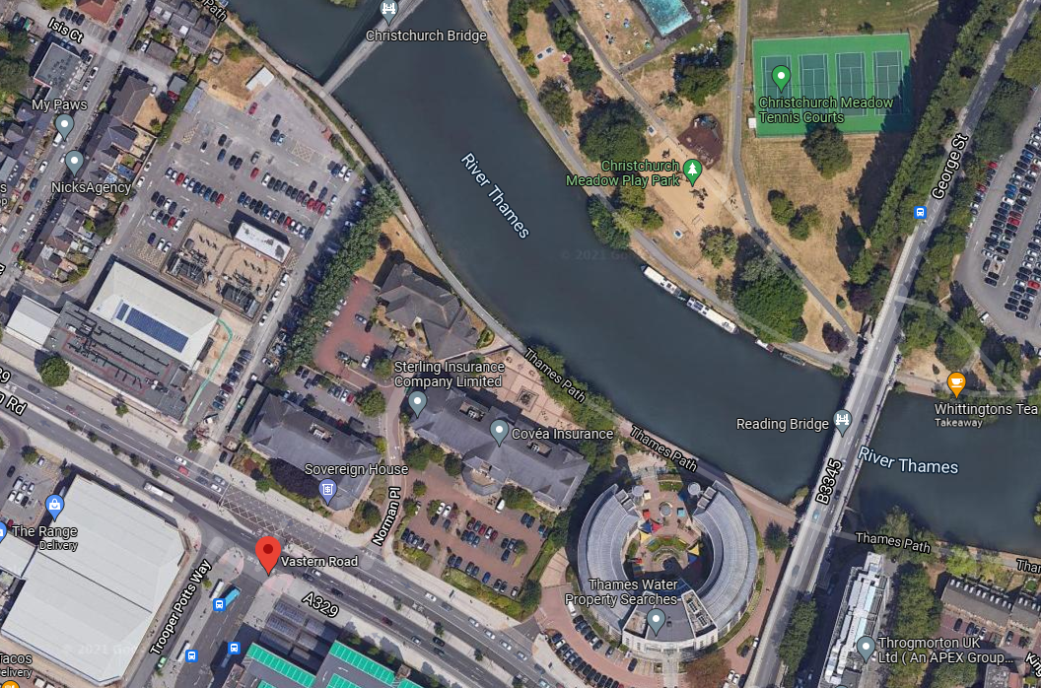

Photo Location 2

Photo Location 1

**Photo from Location 1**

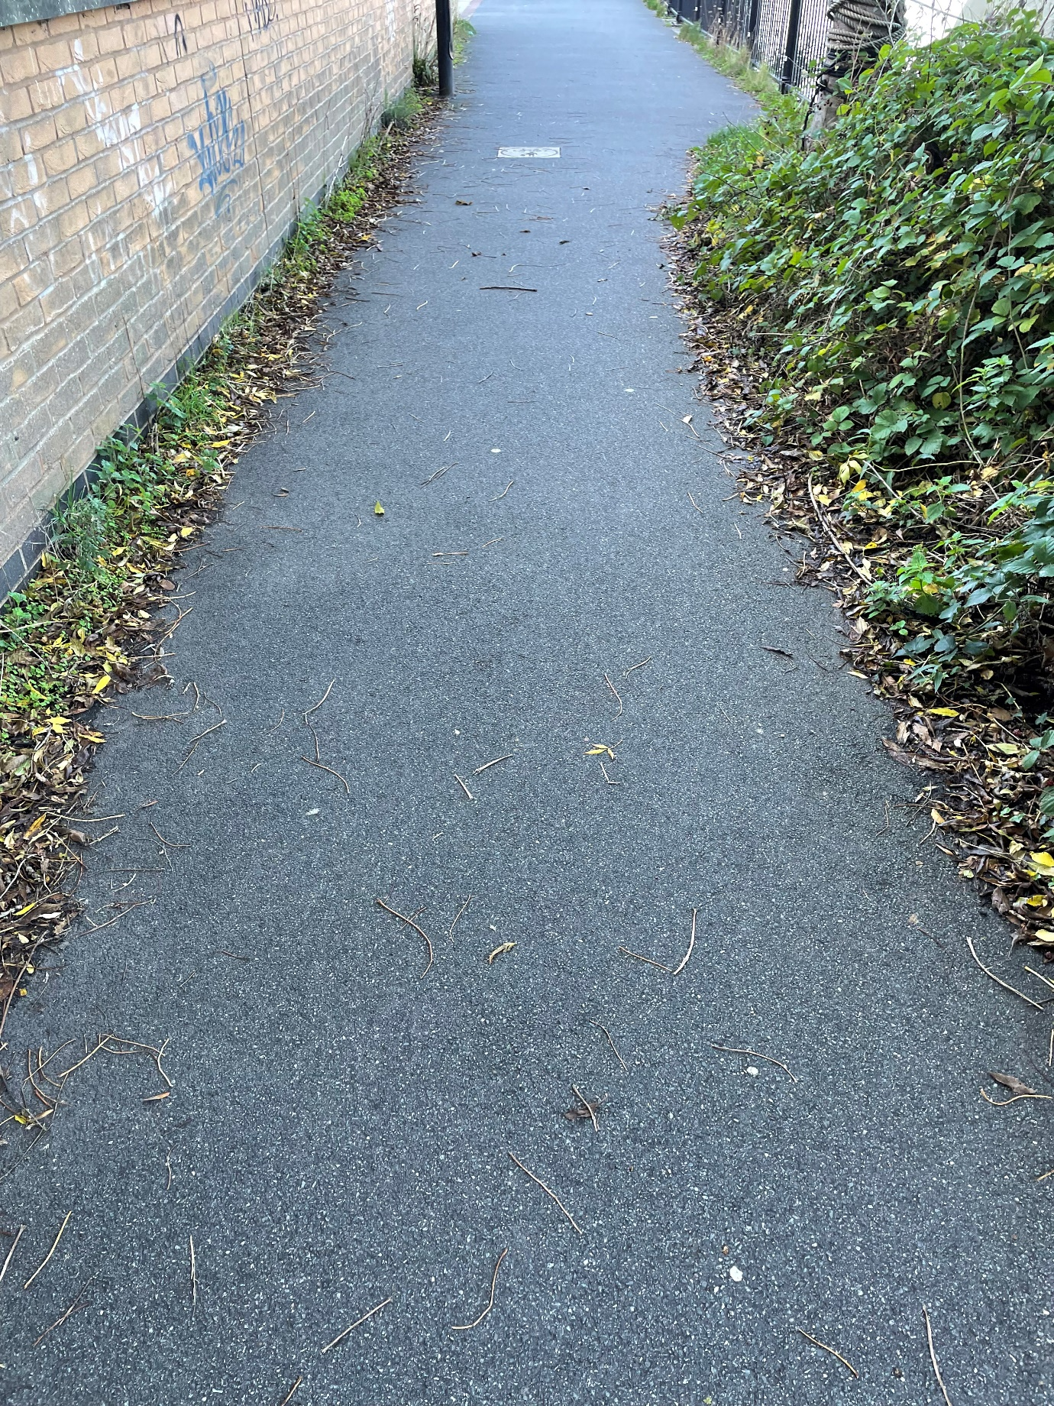

2m Footway / Cycle Width

**Photo from Location 2**

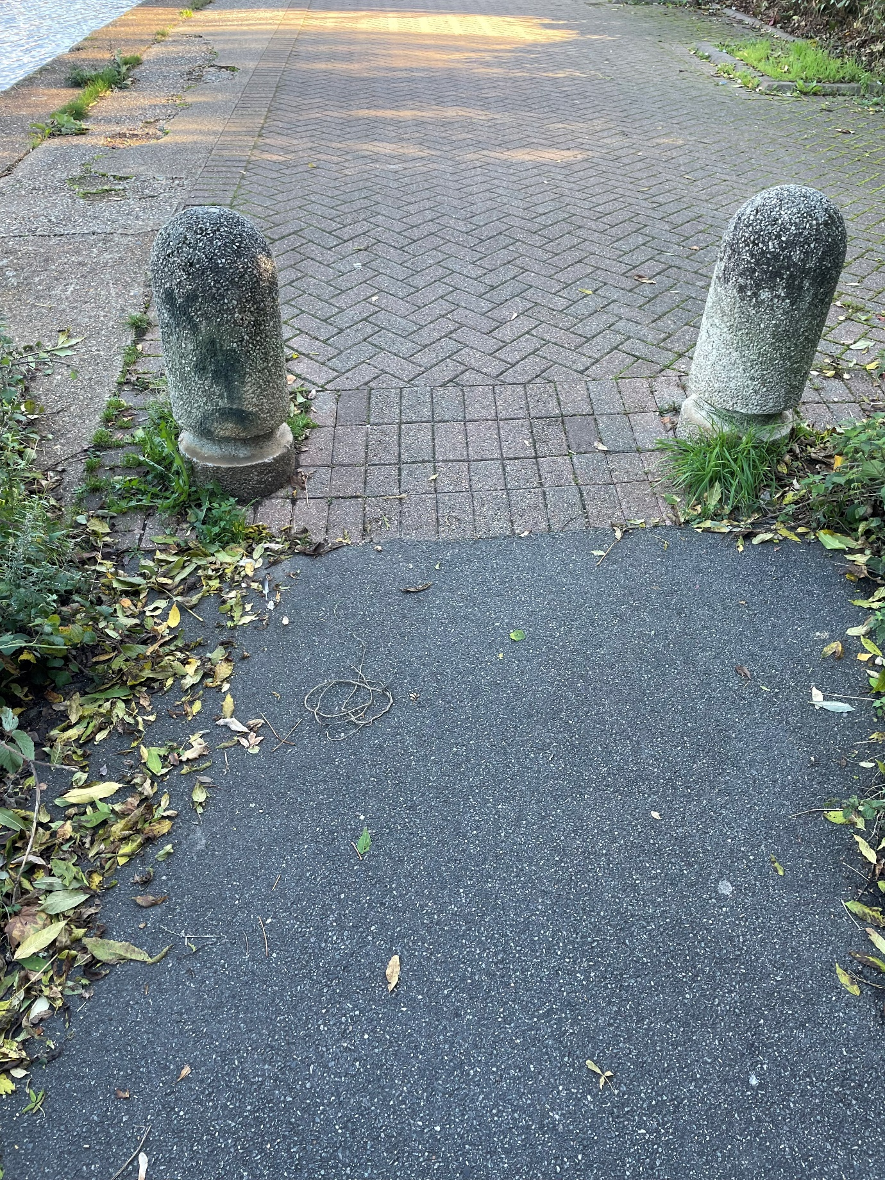

1.2m Footway / Cycle Width