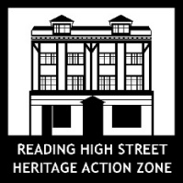
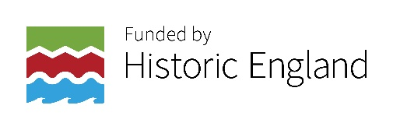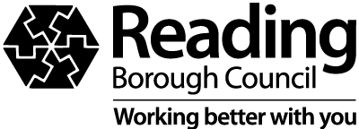
Expression of Interest Form
Group or organisation name:
Contact name:
Contact email address:
Contact number:

- What’s your idea?

2. Who in your group and if applicable the wider community will your project engage?

3. Do you have an artist of creative practitioner or arts organisation that you would like to work with – Yes/No

If you yes – please give their name, art form and web page address and state if they are based in Reading or not.

I give Reading Borough Council permission to contact me by phone Yes/No, by email Yes/No

Signature:
Print name:
Date:

Deadline date for submission – 5pm on Monday 18th July 2022
Please send completed forms to HSHAZ@reading.gov.uk

