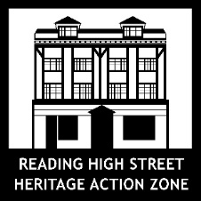

HSHAZ Small Grants Selection Criteria

Quality: The proposal is clear and fits in with the above brief  Artistic Quality | - Submission of a covering letter clearly addressing application points in brief  - Consistency with the brief, examples of previous arts activity/activities have been considered in relation to the aims of the brief  - Demonstrable capacity to deliver the project within timescale and budget  - Has provided case studies/references/images of previous work/links to webpage/links to similar previous work.
Experience: How much experience the artist has had in previous similar projects | - Previous experience of successfully shaping and producing (planning, facilitating and evaluating) inspiring and inclusive co-created arts projects with communities  - Submission of a detailed CV with reference to projects evidencing work of a similar nature  - Demonstrable effective project management skills and knowledge of evaluation techniques.
Participant Reach and Engagement: a clear understanding of who it is you are reaching but also how embedded the artist is in their community on the Oxford Road | - Examples of previous arts activity/activities shows ability to successfully work with communities, shaping and adapting projects to meet their needs and create cultural activities that inspire and are meaningful and relevant to them  - Details of benefits project will give the community  - Demonstrable knowledge and understanding of the Oxford Road Community.  - Strong interpersonal skills and communication skills.
The originality of the project | - Artist/creative practitioner demonstrates understanding of the desire to create excellent and inspiring co-created participatory arts experiences with communities that addresses the aims of the HSHAZ Cultural Programme  - Previous experience of collaborative working brokering and strengthening new relationships.
Added value | - Candidate demonstrates that extra special ability and/or that they have gone above and beyond e.g. training and/or upskilling for community groups, offer arts space free of charge to the community.
Early Career Artists/Creative Practitioners only | Artist/Creative Practitioner:  - Has clearly identified gaps in their skills and experience  - Has articulated how the support from Culture Mix Arts will enable them to bridge these gaps and fulfil the brief.

