Reading Integration Board (RIB) –Project Grants 2022/23  Monitoring Form | 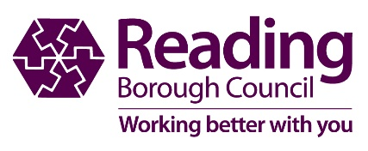

Name of organisation

Correspondence
address
post code
contact information | main contact |  |  | second contact
Name
Tel
Email
Amount of grant awarded: | £ | Decision Book  Date (office use only): |  |  | _ _ / _ _ / _ _ _ _
Purpose for which grant was given

special condition/s of grant (if any)

WHY WE NEED MONITORING INFORMATION

The Council monitors all grants made, as it involves the spending of public monies. Please complete this form as fully as possible in order to confirm that the grant was spent on the purpose for which it was awarded.

Your monitoring information will also help us assess how Reading Integration Board’s (RIB)

Project Grants 2021/22 are supporting achievement of the RIB Priorities.

- Please list all items purchased and their cost and attach relevant receipt Scans/ Photocopies are acceptable

Financial breakdown for grant (please complete this table in as much detail as possible):

Income | £ amount | Expenditure | £ amount
Total Income |  | Total Expenditure

- Also attach the following:
- A copy of the bank statement/s showing receipt of grant
- A copy of the bank statement/s showing expenditure of grant
□ Examples of publicity displaying the Borough Council logo, including on your organisation’s website if applicable

- Please outline the project undertaken, it’s aim(s) and to what degree this was achieved.

As well as how your project was assisted by the the grant awarded by RBC.

Project Name:
Project aim(s):
What were the outcomes of your project, emphasising successes and any challenges faced (500 words)
How many people have been supported/benefitted?

If you have any queries regarding completion of this form contact
Beverley Nicholson, 0118 937 3643 or beverley.nicholson@reading.gov.uk

This form should be returned by 29th april 2023 3
(For projects starting in financial year 2022/23)

Please email to: beverley.nicholson@reading.gov.uk

