Classification: OFFICIAL

1

Classification: OFFICIAL

Reading Borough Council Multi Agency Hoarding and Self-Neglect Protocol and Guidance

Document History
Version | Version 1.1
Status | Final
Effective Date | November 2022
Target audience | All Reading Staff and partner agencies
Summary | The aim of this guidance is to act as a guide and toolkit for professionals and agencies to provide a consistent and coordinated approach when working with individuals who demonstrate hoarding behaviours.
Author | Sarah Martin Social Worker and Carole Lee Principal OT (Occupational Therapist)
Partner Agencies | Thames Valley Police, South Central Ambulance Service, Berkshire Health Foundation Trust West of Berkshire Safeguarding Board Buckinghamshire, Oxfordshire and Berkshire West Integrated Care Board, Royal Berkshire Hospital, Royal Berkshire Fire and Rescue, Reading Voluntary Agencies
Review Date | July 2023

Summary
The aim of this protocol is to act as a guide and toolkit for professionals and agencies to provide a consistent and coordinated approach when working with individuals who demonstrate hoarding behaviours.
This document is designed to be both a multi-agency guide to issues of hoarding and self- neglect as well as offering procedural guidance for case workers in Adult Social Care. It is recognised that it is often housing, community and voluntary agencies who become concerned about people who self-neglect, and that sometimes it is these agencies that are best placed to form non-threatening relationships with people over time to persuade them to accept help.
This guidance should be read in conjunction with the following: https://www.sabberkshirewest.co.uk
West Berkshire Procedures and Appendixes (berkshiresafeguardingadults.co.uk) Self-Neglect | Safeguarding Adults Board (sabberkshirewest.co.uk)
Local guidance, Self – Neglect and Hoarding Threshold tool. https://www.sabberkshirewest.co.uk/media/1175/self-neglect-and-hoarding-threshold- tool.pdf
https://www.sabberkshirewest.co.uk/practitioners/supporting-individuals-to-manage-risk-and- multi-agency-framework-marm/
Reading Borough Council” Difficult to Engage Guidance” see Appendix 7
Information Governance: Reading Procedures and Appendixes (berkshiresafeguardingadults.co.uk)
Information sharing: pan-berkshire-sab-information-sharing-protocol-v10.pdf (berkshiresafeguardingadults.co.uk)

Contents

Reading Borough Council Multi Agency Hoarding and Self-Neglect Protocol and Guidance 1
Summary 2
Contents 2
Introduction 3
Aims of a multi-agency protocol 4
Definition of Hoarding 4
Types of Hoarding 5
Characteristics Of Hoarding 5
Hoarding Insight Descriptors 6
Impact on executive function 6
Good Practice principles 7
Mental Capacity 7
Safeguarding 9
Hoarding and child protection 10
Role of Adult Social Care 10
Lead on safeguarding 10
Legal Frameworks 11
Multi-Agency Process 12
Multi-Agency Meeting 12
Review Meeting 13
The Pathway 13
Clutter rating guidance/descriptors 26
Appendix 1: Reading Borough Council referral for Multi - Agency Meeting self- neglect and hoarding 33
Appendix 3: Safeguarding consultation document (case closure) 39
Appendix 4: Ice breaker to be used by individuals to talk to health (or other) professionals 40
Appendix 5: Guidance Questions for Practitioners 42
Appendix 6: Readiness to Change Questionnaire/ Evaluation (self-assessment tool to be used with the individual) 43
Appendix 7: Residents who do not engage with Social Care 46
Appendix 8: Information sharing policy/guidance 49
Appendix 9: Local Organisations / Resources 49

Acknowledgements

Introduction
This protocol has been developed as a response to a growing understanding of the complexity of factors that lead to individuals to demonstrate hoarding behaviours and as a result self- neglect; the role and responsibilities of those organisations involved with their care, and a recognition that many of the responses employed previously have not achieved effective outcomes for the person.
It is estimated that 2-5% of the population are thought to have hoarding behaviours, in Reading we estimate this could be up to 8,000 individuals based on the current population (161,780 ONS mid-year estimates 2019). Supporting this group effectively and providing appropriate care and support, by addressing the causes together with the effects of hoarding, will have a wide-ranging impact for both sufferers and professionals.

This is a multi-agency protocol, developed in consultation with Reading Borough Councils partner agencies
This document must be read in conjuncture with SAB (Safeguarding Adults Board) West Berks Local Guidance, Self-Neglect and Hoarding Threshold tool

Aims of a multi-agency protocol
The aims are to:
Create a safer and healthier environment for those directly and indirectly affected by hoarding behaviour by generating a multi-agency awareness of how to respond to hoarding and self- neglect.
Imbed a person centred and outcome-based approach which is proportionate to the presenting risk.
Work with individuals to prevent crisis through early prevention and identification of need.
Provide a support network for agencies and staff dealing with hoarding cases and enable sharing of best practice.
Introduce standardised practice for all partners and have clear outlines for agency roles and responsibilities, which promotes transparency.
Provide working tools for assessment, information gathering and engaging individuals.
To provide clear processes for working with individuals with hoarding disorder, for planning, coordinating, assessment, and managing risk. To consider diagnosis and treatment where relevant.
Improve coordination and communication between agencies.
Establish best practice and commit to ongoing learning relating to hoarding behaviour
Encourage and develop creative and effective pathways to engage with and maintain individuals
To collate data and information on the prevalence and needs of those with hoarding behaviour.
Fulfil the local authority's and other statutory agencies collective responsibility towards all adults in the community who display hoarding behaviours and self-neglect
Align with national and local policies – the Care Act, Mental Capacity Act, Better Care key message “enable people to stay well, safe and independent at home for longer,” West Berks Safeguarding Board priorities. https://www.sabberkshirewest.co.uk/practitioners/self-neglect- new-added-august-2022/

Definition of Hoarding
Hoarding Disorder has in the past been considered a form of obsessive-compulsive disorder (OCD). It is now considered a standalone mental disorder and is included in the 5th edition of the DSM 2013. However, hoarding can also be a symptom of other mental disorders.
Hoarding Disorder is distinct from collecting and is also different from people whose property is cluttered or messy. It is not simply a lifestyle choice. The main difference between a hoarder and a collector is that hoarders have strong emotional attachments to their objects which are in excess of their real value.

Hoarding does not favour agender, age, ethnicity, socio-economic status, educational
/occupational history, or tenure type.
Anything can be hoarded, in various areas, including the resident’s property, garden or communal areas. Commonly hoarded items include, but are not limited to:
- Clothes
- Newspapers, magazines, or books
- Bills, receipts, or letters
- Food and food containers
- Animals
- Medical equipment
- Collectibles such as toys, video, DVD, or CDs
There can be other explanations for situations that may initially present as hoarding disorder such as significant changes to an individual’s health and social circumstances and this needs to be considered.

Types of Hoarding
Different items can be hoarded, they may include -:
Inanimate objects: This is the most common. This could consist of one type of object or collection of a mixture of objects, such as old clothes, newspapers, receipts, food, containers, DVDs, CDs and VHS tapes, computers, and electronic storage devices.
Animals: Often accompanied by poor standards of animal care. The hoarder is unable to recognise that the animals are at risk because they feel they are saving them. The homes of animal hoarders are often subject to the accumulation of animal faeces and infestation by insects.
Data: Data hoarding could present with the storage of data collection equipment such as computers, electronic storage devices or paper. A need to store copies of emails, and other information in an electronic format. Whilst it may not seem as significant as inanimate and animal hoarding, people that do hoard data could still present with same issues that are symptomatic of hoarding
Waste: Accumulating human waste (both urine and faeces) is a less common form of hoarding.

Characteristics Of Hoarding
The characteristics of hoarding are:
- Fear and anxiety: compulsive hoarding may have started as a learnt behaviour or following a significant event such as bereavement.
- The person who is hoarding feels that buying or saving things will relieve anxiety and fear. The hoarding effectively becomes their comfort blanket.
- Any attempt to discard the hoarded items can induce difficult feelings, varying from mild anxiety to a full panic attack.
- Long term behaviour pattern: developed over many years or decades of ‘buy and drop.’ Collecting and saving with an inability to throw away items without experiencing fear and anxiety.
- Excessive attachment to possessions: people who hoard may hold an inappropriate emotional attachment to items.

- Indecisiveness: people who hoard may struggle with the decision to discard items that are no longer necessary, including rubbish.
- Unrelenting standards: people who hoard will often find faults with others; requiring others to perform to excellence while struggling to organise themselves and complete daily living tasks.
- Socially isolated: people who hoard will typically alienate family and friends and may be embarrassed to have visitors. They may refuse home visits from professionals, in favour of office-based appointments.
- Large number of pets: people who hoard may have many animals that can be a source of complaints by neighbours. They may be a self-confessed ‘rescuer of strays.
- Mentally competent: people who hoard are typically able to make decisions that are not related to hoarding.
- Extreme Clutter: hoarding behaviour may be in a few or all rooms and prevent them from being used for their intended purpose.
- Churning: hoarding behaviour can involve moving items from one part of the property to another, without ever discarding them.
- Self-care: a person who hoards may appear unkempt and dishevelled, due to lack of bathroom or washing facilities in their home. However, some people who hoard will use public facilities to maintain their personal hygiene and appearance.
- Poor insight: a person who hoards will typically see nothing wrong with their behaviours and the impact it has on them and others.

Hoarding Insight Descriptors
Good or fair insight: The client recognises that hoarding-related beliefs and behaviours (relating to difficulty discarding items, clutter, or excessive acquisition) are problematic. The client recognises these behaviours in themselves.
Poor insight: The client is mostly convinced that hoarding-related beliefs and behaviours (relating to difficulty discarding items, clutter, or excessive acquisition) are not problematic, despite evidence to the contrary. The client might recognise a storage problem but has little self-recognition or acceptance of their own hoarding behaviour.
No insight: The client is convinced that hoarding-related beliefs and behaviours (relating to difficulty discarding items, clutter, or excessive acquisition) are not problematic despite evidence to the contrary. The client is completely accepting of their living environment despite it being hoarded and a risk to health.
Detached with assigned blame; The client has been away from their property for an extended period. The client has formed a detachment from the hoarded property and is now convinced a 3rd party is to blame for the condition of the property. For example, a burglary has taken place.

Impact on executive function
Some individuals who hoard will acknowledge they have some hoarding behaviours but have deficits in executive functioning with planning, and decision-making difficulties. This may limit the ability of individuals with hoarding disorders to discard and organize their possessions. Individuals with significant hoarding have been found to have more difficulty initiating and completing tasks and problems with indecision.

Good Practice principles
(Self-neglect policy and practice: key research messages, SCIE (Social Care Institute for Excellence), 2015)
- Taking the time to build rapport and a relationship of trust, through persistence, patience, and continuity of involvement. The theme that emerged most consistently in the research carried out by Braye, Orr and Preston Shoot in 2014 was the importance of establishing a relationship to secure engagement and achieving interventions that could make a difference
- Trying to ‘find’ the whole person and to understand the meaning of their self-neglect in the context of their life history, rather than just the need that might fit into an organisation’s specific role
- Engaging with the individual’s family/friends/support network (with the person’s consent). Their knowledge and understanding of the person may assist with understanding the reasons for self-neglect and they may be best placed to provide support
- Working at the individual’s pace and being able to spot moments of motivation that could facilitate change, even if the steps towards it are small
- Offering choices and having respect for the individual’s judgements on the most appropriate form of help even when coercive measures are being taken.
- The degree to which the person is treated with respect can go a long way in creating a beneficial outcome ensuring an understanding of the nature of the individual’s mental capacity in respect of self-care decisions being honest, open, and transparent about risks and options having in-depth understanding of legal mandates providing options for intervention
- Making use of creative and flexible interventions, including family members and community resources where appropriate
- Engaging in effective multi-agency working to ensure inter-disciplinary and specialist perspectives, and coordination of work towards shared goals. If there are children living in the home of someone who self-neglects, then children’s services should be informed and from part of the multi-agency response. For good practice to occur there is a need for:
- Flexibility (to fit individual circumstances)
- Negotiation (of what the individual might tolerate)
- Proportionality (to act only to contain risk, rather than to remove it altogether, in a way that preserves respect for autonomy).
- The worker should:
  - show humanity
  - be reliable
  - show empathy
  - demonstrate patience
  - be honest
  - work at the individual’s own pace.

Mental Capacity
This protocol stresses the importance of good capacity assessment. Often people may have an initial presentation of making a capacitated choice when refusing help but more detailed assessment, if this can be achieved, may indicate the person’s decision making is impaired; for example, because of an executive disfunction. This may be particularly true of people with

a hoarding disorder. It is important to balance people’s right to make choices about how they live their life with their protection, especially if they are vulnerable. Robust assessment of the degree of risk and proportionality in intervening is key.
The Mental Capacity Act 2005 (MCA) provides a statutory framework for people who lack capacity to make decisions for themselves. The Act has 5 statutory principles, and these values underpin the legal requirements of the act. They are:
- A person must be assumed to have capacity unless it is established that they lack capacity.
- The person is not to be treated as unable to decide unless all practical steps have been taken without success.
- A person is not to be treated as unable to decide merely because they make an unwise decision.
- An act done or decision made, under this act for, or on behalf of a person who lacks capacity must be done or made in his or her best interests.
- Before the act is done, or the decision is made, regard must be had to whether the purpose for which it is needed can be as effectively achieved in a way that is less restrictive of the person’s rights and freedom of action.

When a person’s hoarding behaviour poses a serious risk to their health and safety, professional intervention will be required. Any proposed intervention or action must be with the person’s consent, except in circumstances where a local authority or agency exercises their statutory duties or powers. In extreme cases of hoarding behaviour, the very nature of the environment should lead professionals to question whether the client has capacity to consent to the proposed action or intervention and trigger an assessment of that person’s mental capacity. This is confirmed by The MCA Code of Practice which states that one of the reasons why people may question a person’s capacity to make a specific decision is ‘the person’s behaviour or circumstances cause doubt as to whether they have capacity to make a decision’ (4.35 MCA Code of Practice, p52). Arguably, extreme hoarding behaviour meets these criteria.
Any capacity assessment carried out in relation to hoarding behaviour must be time and decision specific and relate to a specific intervention or action. The professional responsible for undertaking the capacity assessment will be the person who is proposing the specific intervention or action and is referred to as the ‘decision maker’ and is responsible for making the final decision about a person’s capacity.
If the client lacks capacity to consent to the specific action or intervention, then the decision maker must demonstrate that they have met the requirement of the best interests’ ‘checklist.’ Due to the complexity of such cases, there must be a best interest meeting.
In some instances, a psychologist or psychiatrist may be required to complete the MCA.
In particularly challenging and complex cases, it may be necessary for the organisation to seek legal advice and may need to refer to the Court of Protection (CoP) to make the best interest’s decision.
Consideration should be given to the difference between capacity to make a decision (decisional capacity) and carry out that decision (executive capacity).

Safeguarding
This protocol is based on the Six Principles of Safeguarding that underpin all adult safeguarding work.
- Empowerment - Adults are supported to make their own decisions and are provided with support and information.
- Prevention - Strategies are developed to prevent abuse and neglect before harm occurs.
- Proportionate - A proportionate and least intrusive response is made balanced with the level of risk
- Protection – support for those in the greatest need
- Partnerships - Local solutions through services working together within their communities.
- Accountable - Accountability and transparency in delivering a safeguarding response.

Local procedures and processes for safeguarding can be found here Home | Safeguarding Adults Board (sabberkshirewest.co.uk)
https://www.sabberkshirewest.co.uk/practitioners/supporting-individuals-to-manage-risk-and- multi-agency-framework-marm/
Self-neglect covers a wide range of behaviours including hoarding. The Care Act 2014 clarified the position of self-neglect and safeguarding. Under the Act, self-neglect now falls under the definition of causes to make safeguarding enquiries. However, Care and Support Statutory Guidance (2016) clarified that self-neglect may not necessarily prompt an enquiry under section 42 of the Care Act (often referred to as a ‘Section 42 enquiry’).
An assessment should be made on a case-by-case basis, and a decision on whether a response is required under safeguarding will depend on the adult’s ability to protect themselves and the impact of their hoarding on their environment and their wellbeing.
However, there may come a point when they are no longer able to do this without external support. Section 42 of the Care Act states:
‘Enquiry by local authority(1) This section applies where a local authority has reasonable cause to suspect that an adult in its area (whether or not ordinarily resident there) – (a) has needs for care and support (whether or not the authority is meeting any of those needs), (b) is experiencing, or is at risk of, abuse or neglect, and (c) as a result of those needs is unable to protect himself or herself against the abuse or neglect or the risk of it.(2) The local authority must make (or cause to be made) whatever enquiries it thinks necessary to enable it to decide whether any action should be taken in the adult’s case (whether under this Part or otherwise) and, if so, what and by whom.
’There is no one piece of legislation that easily provides a solution in all cases relating to Hoarding, and that due care is needed when considering restricting a person’s autonomy and right to private and family life under Article 8 of the Human Rights Act. However, this right is a qualified right and must be balanced against a public authority’s duty positively to promote people’s rights and to take account of the wellbeing principle that runs throughout the Care Act.
Consideration of Article 8 must also not limit consideration of Article 2, the Right to Life. What is important is that any limitation on Article 8 must be in accordance with the law and necessary and proportionate.

Hoarding and child protection
When working with an adult who hoards consider the welfare of any children who may be affected by these issues and discuss your concerns with Brighter Future for Children’s Single Point of Access (CSPoA) who deal with concerns about a child (pre-birth to 18 years old) in Reading.
This page gives professionals details on how to contact us or make a referral if a child or young person in Reading:
- may need additional support
- may be being abused or neglected
- needs safeguarding of any kind.
Adult social services must work closely with children’s assessment and child protection teams in such cases.
https://brighterfuturesforchildren.org/report-or-refer-concerns-about-a-child/

Role of Adult Social Care
The Care Act 2014 sets out in one place, local authorities’ duties in relation to assessing people’s needs and their eligibility for publicly funded care and support.
Under the Care Act 2014, local authorities must:
- Carry out an assessment of anyone who appears to require care and support, regardless of their likely eligibility for state-funded care.
- Focus the assessment on the person’s needs and how they impact on their wellbeing, and the outcomes they want to achieve.
- Involve the person in the assessment and, where appropriate, their carer or someone else they nominate.
- Provide access to an independent advocate to support the person’s involvement in the assessment if required.
- Consider other things besides care services that can contribute to the desired outcomes (e.g., preventive services, community support)

Lead on safeguarding:
If the individual meets the threshold for a safeguarding referral:
Under the Care Cat 2014 local authorities and other parts of the system should protect adults at risk of abuse or neglect and must:
- Lead a multi-agency local adult safeguarding system that seeks to prevent abuse and neglect and stop it quickly when it happens
- Make enquiries, or request others to make them, when they think an adult with care and support needs may be at risk of abuse or neglect and they need to find out what action may be needed
- Arrange for an independent advocate to represent and support a person who is the subject of a safeguarding enquiry or review, if required

Legal Frameworks
AGENCY | LEGAL POWER AND ACTION | CIRCUMSTANCES REQURING INTERVENTION  ‐
Environmental health | Power of entry/ Warrant (s.287 Public Health Act)  Gain entry for examination/ execution of necessary work required under Public Health Act Police attendance required for forced entry | Non engagement of Individual. To gain entry for examination/execution of necessary work  (All tenure including Leaseholders/ Freeholders)
Environmental health | Power of entry/ Warrant (s.239/240 Public Health Act)  Environmental Health Officer to apply to Magistrate. Good reason to force entry will be required (all party evidence gathering) Police attendance required | Non engagement of individual/entry previously denied. To survey and examine  (All tenure including Leaseholders/ Freeholders)
Environmental health | Enforcement Notice (s.83 PHA 1936) Notice requires person to comply. Failure to do so can lead to council carrying out requirements, at own  expense; though can recover expenses that were reasonably incurred | Filthy or unwholesome condition of premises (articles requiring cleansing or destruction) Prevention of injury or danger to person served.  (All tenure including Leaseholders/ Freeholders/Empty properties)
Environmental health | Litter Clearing Notice  (Section 92a Environmental Protection Act 1990)  Environmental Health to make an assessment to see if this option is the most suitable. | Where land open to air is defaced by refuse which is detrimental to the amenity of the locality. An example would be where hoarding has spilled over into a garden.
Police | Power of Entry (S17 of Police and Criminal Evidence Act)  Person inside the property is not responding to outside contact and there is evidence of danger. | Information that someone was inside the premises was ill or injured and the Police would need to gain entry to save life and limb
Fire Service | Prohibition or Restriction of use (Regulatory Reform (Fire Safety) Order 2005)  The fire brigade can serve a prohibition or restriction notice to an occupier which will take immediate effect. In some  circumstances this can apply to domestic  premises including single private dwellings where the appropriate criteria of risk to  relevant persons apply. | If a premise involves risk to persons so serious that the use of the premises ought to be Prohibited or Restricted notice can be  served on the responsible person (owner/occupier).
Animal Welfare agencies such as RSPCA/Local authority e.g., Environmental Health/DEFRA | Animal Welfare Act 2006 Offences (Improvement notice)  Education for owner is the preferred initial step, Improvement notice issued and monitored, if not complied with can lead to a fine or imprisonment | Cases of Animal mistreatment/ neglect.  The Act makes it not only against the law to be cruel to an animal, but that a person must ensure that the welfare needs of the animals are met.
Housing | Housing Act 2004. Allows LA to carry out risk assessment of any residential premises to identify any hazards that would likely cause harm and to take enforcement action where necessary to  reduce the risk. if the hazard is ‘Cat 1’ there is a duty to take action. If ‘Cat 2’ there is power to take action.
Mental Health | Mental health Act 1983 Section 135(1) Provides for a police officer to enter a premise, search for, and remove a person to a place of safety if certain grounds met.  Must be accompanied by an AMHP and doctor. | Evidence must be presented to a magistrate by an AMHP that there is reasonable cause to believe that a person is suffering from mental disorder and is  being – ill-treated, neglected, being kept other than under proper control or if living alone is  unable to care for themselves and that the action is a proportionate response to the risks involved.

ALL | Mental Capacity Act 2005. A decision can be made about what is in the best interests of an incapacitated individual by an appropriate decision maker. It is important to follow the empowering principals of the Act and take the least restrictive option. | A person who lacks capacity to make decisions about their care and where they might live is  refusing intervention and at high risk of harm as a result.

Multi-Agency Process
Working with individuals who have Hoarding Behaviours can be very complex. In order to improve outcomes for those individuals, a multi-agency approach must be taken. The purpose of using a multi-agency or multi-disciplinary team (MDT) approach is to bring agencies, the client, and their advocate together to find solutions.
The MDT brings together all of those involved with the individual. The MDT should be arranged and lead by the agency who knows the individual and has the “best “understanding of the associated risks. The MDT meeting will enable information sharing, a better understanding of risks, what has already been tried, coordinate an approach, and agree action going forward to reduce risk and improve the circumstances of the individual.
Use “The Referral for Hoarding Multi-Disciplinary Meeting” to share information and coordinate an MDT. See Appendix 1
Discussions and decisions made should be clearly recorded on an individual’s records and using the Muti Disciplinary Strategy Meeting Minutes to record any action required to minimise risks.
As individuals often struggle to recognise that their situation is problematic it is important to understand their own perception of the situation, their goals, and priorities and not to make judgements or assumptions.
If the MDT recognises that action cannot be taken to reduce the risks, either due to the severity of the situation or because the individual does not engage with agencies, or the person is believed to have capacity to understand the risks posed to them a MARM (Multi Agency Risk Management) should be arranged and led by Reading Adult Social Care
Where possible the individual should be informed and included, and outcome of meetings shared.

Multi-Agency Meeting
- The MDT will be coordinated and chaired by the lead agency and the purpose will be to bring agencies and where possible, the individual together, to consider the situation, risks, and proposed actions.
- If the individual is not invited to the meeting, the reasons should be recorded
- All agencies involved with the individual or others in the home, should be invited.
- The MDT referral should be completed by the agency who raised the initial concerns and meeting should be recorded follow the Multi Agency Meeting Agenda.
- The action plan, (with agreed timescales and named workers), existing protective factors, current risk and views of the individual should all be recorded on Mosaic.
- The most appropriate agency or worker should be identified to be the lead contact with the individual and this should include keeping them informed of, or making sure they understand, decisions that have been made.
- A review date should be set

- Following the meeting, minutes will be sent to all attendees

Review Meeting
- Updates should be provided by all agencies, against actions set at the MDT
- New information to be shared
- Risk assessments and actions, including appropriate worker should be updated
- Where actions have not been successful, alternative approaches should be considered and / or consideration given to referral to MARM/safeguarding where not already involved
- All attendees to keep line managers updated
- Notes to be sent to attendees and where appropriate to be recorded
- Further date for review set
- Review meetings to be ongoing until risks are managed to the satisfaction of the MDT
- At this point consideration should be given to ongoing or additional support that might be available and appropriate.

The Pathway

New Referrals pathway
If an individual is identified as demonstrating hoarding behaviours and as consequence self- neglect and is unknown or closed to Adult Social Care, they should be referred to the Advice and Wellbeing Hub in the first instance for advice and support and assessment under the Care Act. Please use the clutter index tool, Decision Making Toolkit and Referral form for Hoarding Multi-Disciplinary Meeting to support your referral.
To refer to Reading Borough Council Advice and Wellbeing Hub: About Adult Social Care Services - Reading Borough Council or ring 0118 937 3747

Hospital discharge pathway
If the hoarding and self-neglect is identified as part of a hospital discharge the Discharge to Assess Team allocated worker will complete the initial assessment, risk assessment, impact, and MDT meeting to establish risk and actions required for safe return home.
The same process will be followed for other Adult Social Care Teams including Locality Team and Mental Health Teams.
Please use the clutter index tool, Decision Making Toolkit and Referral form for Hoarding Multi-Disciplinary Meeting to support your referral.

Safeguarding threshold pathway
If the threshold is reached for safeguarding:
If allocated to a worker in Reading Adult Social Care the allocated worker will open a safeguarding concern and progress depending on risks using the principals and tools in this protocol. Use the Clutter Index Tool, Mental Capacity, Decision Making Toolkit, and referral form for Hoarding Multi-Disciplinary Meeting.

If unknown or closed to Adult Social Care a safeguarding referral must be made see below for details:
Contact number 0118 937 3747, or complete the professional referral form: https://self.reading.gov.uk/service/Adults_safeguarding_professional_referrals
or email CSAAdvice.Signposting@reading.gov.uk
If you need advice around a possible safeguarding matter, please call Reading Borough Councils Adults Safeguarding Professionals’ line on 0118 9376550
When assessing for risk please refer to: https://www.sabberkshirewest.co.uk/media/1624/self-neglect-and-hoarding-safeguarding- pathway-toolkit-v10.docx
Consider risks to individuals and others, mental capacity, levels of engagement and protective factors.
Please use the clutter index tool, Decision Making Toolkit and Referral form for Hoarding Multi-Disciplinary Meeting to support your referral.
To refer to Reading Safeguarding Team : https://self.reading.gov.uk/service/Adults_safeguarding_professional_referrals or ring 0118 937 3747 or for out of hours, contact the Emergency Duty Team on 01344 35199.
Please refer, with consent, anyone at risk for a Safe and Well assessment with Royal Berkshire Fire Service see link https://www.rbfrs.co.uk/your-safety/safety-at-home/book-a- safe-and-well-visit/are-you-a-referring-agency/

Decision Making Toolkit
https://www.sabberkshirewest.co.uk/media/1624/self-neglect-and-hoarding-safeguarding- pathway-toolkit-v10.docx
This toolkit, based on the Wokingham Borough Council toolkit, has been approved by the West of Berkshire Safegaurding Adults Board, to support professionals across the West of Berkshire in their decision making when considering if a safeguarding concern should be raised in response to concerns in regards to vulnerable adults that are or are at risk of self- neglecting and/or hoarding.

The toolkit will ask you to consider the following areas of vulnerability by assessing them under Standard/Moderate/High, guidance is provided throughout:
- Vunerability
- Property
- Health & Safety
- Household functions
- Impact for Others
- Impact for Person Concerned
- Clutter Scale Tool – using the Clutter Image Rating provided by Hoarding Disorders UK
- Mental Capacity

On completion of the toolkit a total risk score will be obtained and advice on what action should be taken in regard to the total score is provided.
Use of this tool is not a substitute for using your professional judgement. This completed document should accompany any referrals and or safeguarding concerns to Adult Social Care (ASC).

The partnership has completed 2 example toolkits based on fictious cases Mr Brown and Mrs Red, please refer to for best practice examples of completed toolkits.

Further information on the partnerships safeguarding policy in regards to self-neglect can be found here.

Vulnerability
Select one from the list below
Rating | Guidance | Tick As  Appropriate | Rationale For Decision
Standard | No ‘care and support needs’ as defined by Care Act 2014, no concerns over mental capacity with regard to accommodation and support  needs.
Moderate | Has ‘care and support needs’ as defined by Care Act 2014, may have mental illness or cognitive decline, may or may not have mental capacity with regard to accommodation and support needs, may have some insight into the problems they face and may be accepting of care and treatment.
High | Has ‘care and support needs’ as defined by Care Act 2014, has mental illness or cognitive decline, lacks or is likely to lack mental capacity with regard to accommodation and support needs, lacks insight into the problems they face and may nor may not be accepting of  care and treatment.

Property
Select one from the list below
Rating | Guidance | Tick As  Appropriate | Rationale For Decision
Standard | Entrances, exits all accessible, functional smoke alarm in situ or Fire Service referral made, household services functional and no concerns about safety, garden is  accessible and functional
Moderate | Only main entrance blocked, interior doors missing or blocked open, one household service is not functional or may not be safe, no functional smoke alarm in situ, garden not accessible, indoor items stored outside, evidence of light structural  damage or damp
High | Limited access due to extreme clutter, interior doors missing or blocked open, garden inaccessible and extremely overgrown, lack of functional smoke alarm, more than one household service not functional or may not be safe, clutter impacting on ventilation, structural damage or outstanding repairs including damp,  indoor items stored outside

Health & Safety
Select one from the list below
Rating | Guidance | Tick As  Appropriate | Rationale For Decision
Standard | Property clean with no odour, no rotting food, no flies or insects, no concerning use of candles, occupants self-caring or receiving appropriate support, appropriate quantities of medication stored and within use by date, use of personal protective equipment not  required
Moderate | Kitchen and bathroom not clean, evidence of offensive odours, unsafe cooking environment, no rotting food, no concerning use of candles, occupants struggling to maintain personal care, some concerns over quantity of medication or storage or use by date, light insect infestation, personal  protective equipment required
High | Human or animal urine or faeces present, excessive odour, evidence of rotting food and/or food waste, unwanted or discarded household items, glass or crockery, inappropriate quantities or storage of medication, concerns over integrity of gas or electric supply, heavy insect  infestation or visible rodent infestation

Household Functions
Select one from the list below
Rating | Guidance | Tick As  Appropriate | Rationale For Decision
Standard | All rooms can be safely used for intended purpose, all rooms rated 0-3 on clutter index, property maintained in accordance with any lease or tenancy agreement, no risk of action by Environmental  Health
Moderate | Kitchen and bathroom not clean, evidence of offensive odours, unsafe cooking environment, no rotting food, no concerning use of candles, occupants struggling to maintain personal care, some concerns over quantity of medication or storage or use by date, light insect infestation, personal  protective equipment required
High | Clutter blocking access or causing obstruction and preventing use of rooms for intended purpose, room(s) rated 6-9 on clutter index, bed(s) inaccessible due to clutter or infestation, toilets/sinks not functioning/usable, no safe cooking environment, household appliances not functioning, occupant using candles, no evidence of housekeeping, broken items not discarded, property not maintained in accordance with lease or tenancy agreement and risk of notice being served  by Environmental Health

Impact for Others
Select one from the list below
Rating | Guidance | Tick As  Appropriate | Rationale For Decision
Standard | There are no other people or animals in the household. Or others are present but there are no concerns around impact on  them
Moderate | There are children or other adults in the household and the current situation may be impacting on their health or wellbeing.  Hoarding likely to be on clutter scale 4 to 7. A multiagency approach may  be helpful
High | There are children or other adults with care and support needs in the household and the current situation is impacting on their health or wellbeing.  Hoarding likely to be on clutter scale 7 to 9

Impact for Person Concerned
Select one from the list below
Rating | Guidance | Tick As  Appropriate | Rationale For Decision
Standard | Person concerned is accepting support and accessing appropriate services. No carer issues. Person concerned has access to community and  social interaction and is able

to contribute to activities of daily living (with appropriate support).
Personal hygiene is
adequate
Moderate | Access or engagement with support is limited or sporadic. There are some concerns around the health or wellbeing of the person concerned. Limited social interaction, no carer present. Ability to contribute to activities of daily living is compromised and personal hygiene is  becoming an issue
High | Person concerned is not engaging with appropriate services and/or is refusing care and support. Health is deteriorating and wellbeing is affected on a daily basis. Person is isolated and is not managing activities of daily living. Hygiene is poor and  causing problems

Using the Clutter Scale Tool, please score each room below
To complete this section please refer to the Clutter Scale Tool created by The International OCD Foundation and were originally from a study by Frost RO, Steketee G, Tolin DF, Renaud S. Development and validation of the Clutter Image Rating. Journal of Psychopathology and Behavioral Assessment. 2008;32:401–417 which will provides example images to rate the
clutter scale.
Score – Risk Key Standard 1-3, Moderate 4-5, High 6-9
Room | Clutter  Score | Is access /exits  compromised? | How high does the  clutter reach? | Risk
Bedroom 1
Bedroom 2

Bedroom 3
Bedroom 4
Hallway
Kitchen
Bathroom
Cloakroom
Lounge
Dining room
Other room (Please
specify)

Mental Capacity
Does the person concerned have mental capacity in respect of the issues / risks identified in
relation to:
 | Yes | No | Unsure (explain why)
Property
Health &
Safety
Household
Functions
Impact on
others
Impact on self
Note: if a person has capacity to make decisions, even if those decisions appear unwise, then you do not have permission to share information or intervene without their consent unless:
- There may be a crime
- There may be risk to others (public interest)
- There may be a risk of significant harm or death (vital interest)
- There is a reasonable concern the person may be experiencing coercion or undue influence around their decision making
If you are unsure whether the person concerned has capacity, you should take advice from your organisations Mental Capacity Lead or Adult Social Care. You should always make sure you advise
the person concerned that you may have to share information with for example, Police, Adult Social

Care, Children's Services, Environmental Health, Fire & Rescue Service, or the RSPCA in certain
circumstances.

Overall Risk Rating
 | Total Number of  Risks | What to do
Standard |  | If the person concerned is scored as Standard risk throughout, it does not require referral to Adult Social Care (ASC), unless specific unmet needs are identified. Those workers involved should continue with preventative work, to; engage with the individual, build rapport, support them to address concerns including increasing  engagement with the community, developing / repairing relationships, accessing health care and improving wellbeing.
Moderate |  | If the person concerned is scored at Moderate risk against 1 or more indicators, a multiagency approach is likely to be required and may need to involve agencies, such as; landlord, Environmental Health, Fire Service, RSPCA etc. The person leading should risk assess, engage available resources, consider, and refer to therapeutic services as appropriate and explore other support networks available. Legal processes may need to be used if appropriate. A referral to ASC may be required and the person leading should  consult with that agency for advice and guidance.
High |  | If the person concerned is scored at High against one of more indicators, a referral to ASC is required and it may (depending on circumstances) require raising a safeguarding concern – Adult Social  Care will be able to advise on this.
Reminder: Use of this tool is not a substitute for using your professional judgement. This completed
document should accompany any referral or safeguarding concern to Adult Social Care.

Self-Assessment Tools
Self-assessment clutter index

Can be completed by an individual themselves, where they are motivated to score their own property or by a professional to form part of the assessment

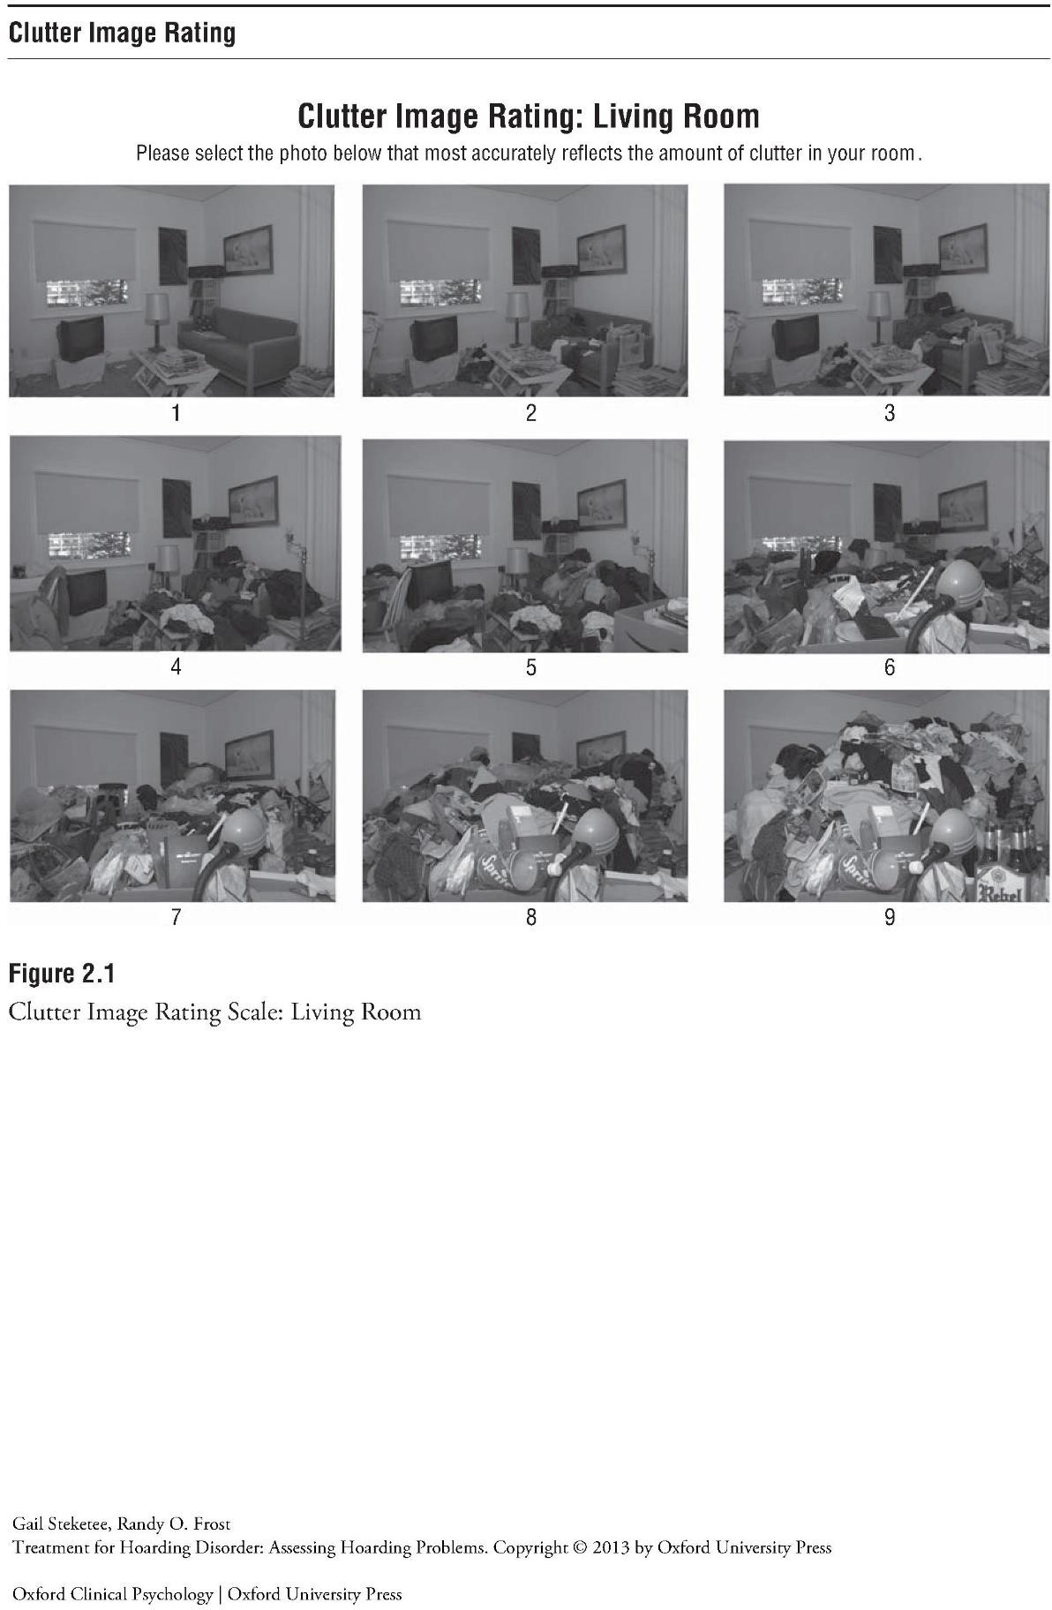

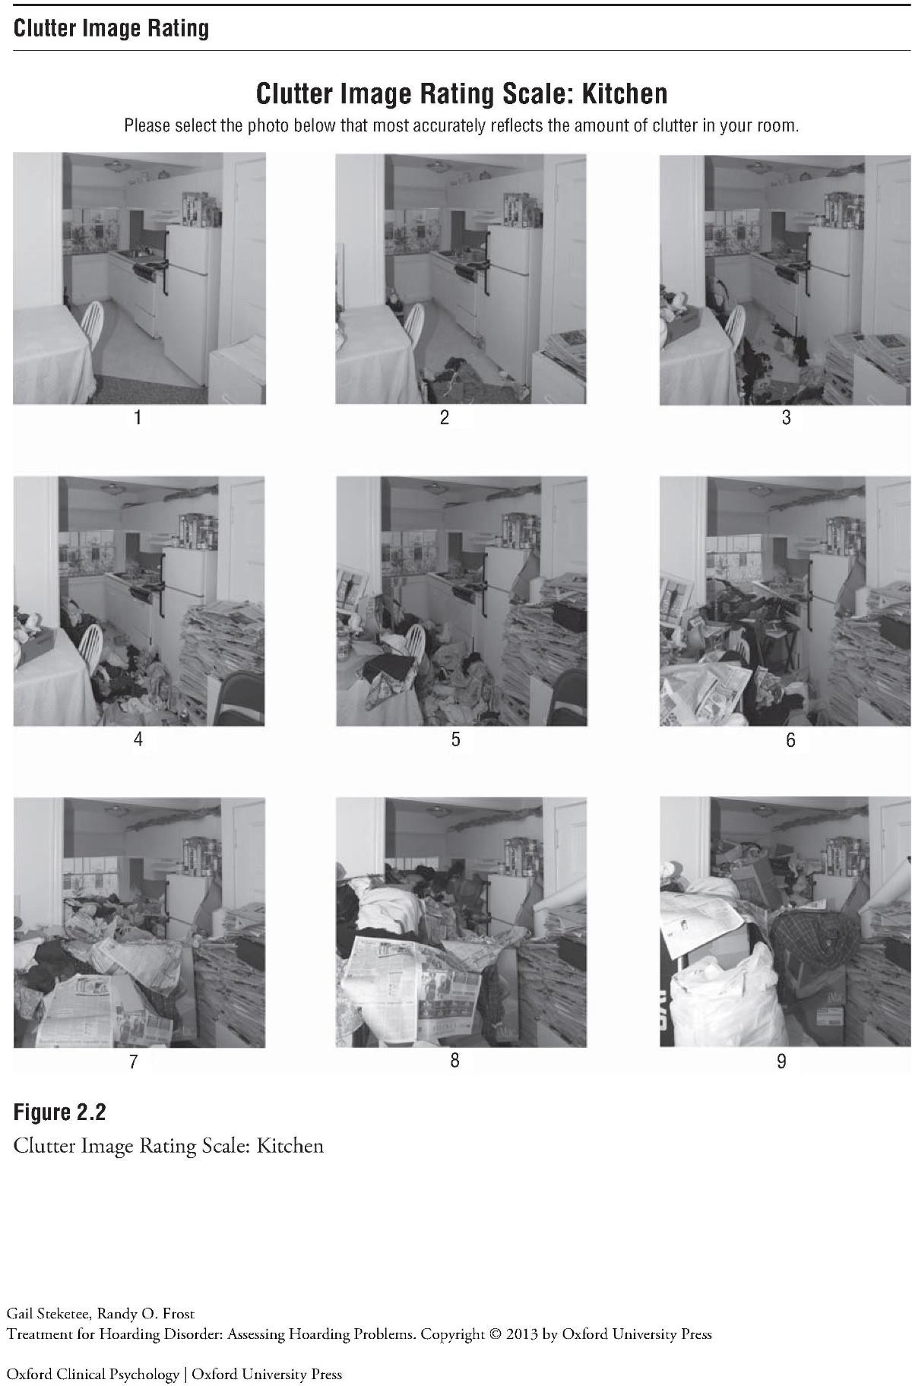

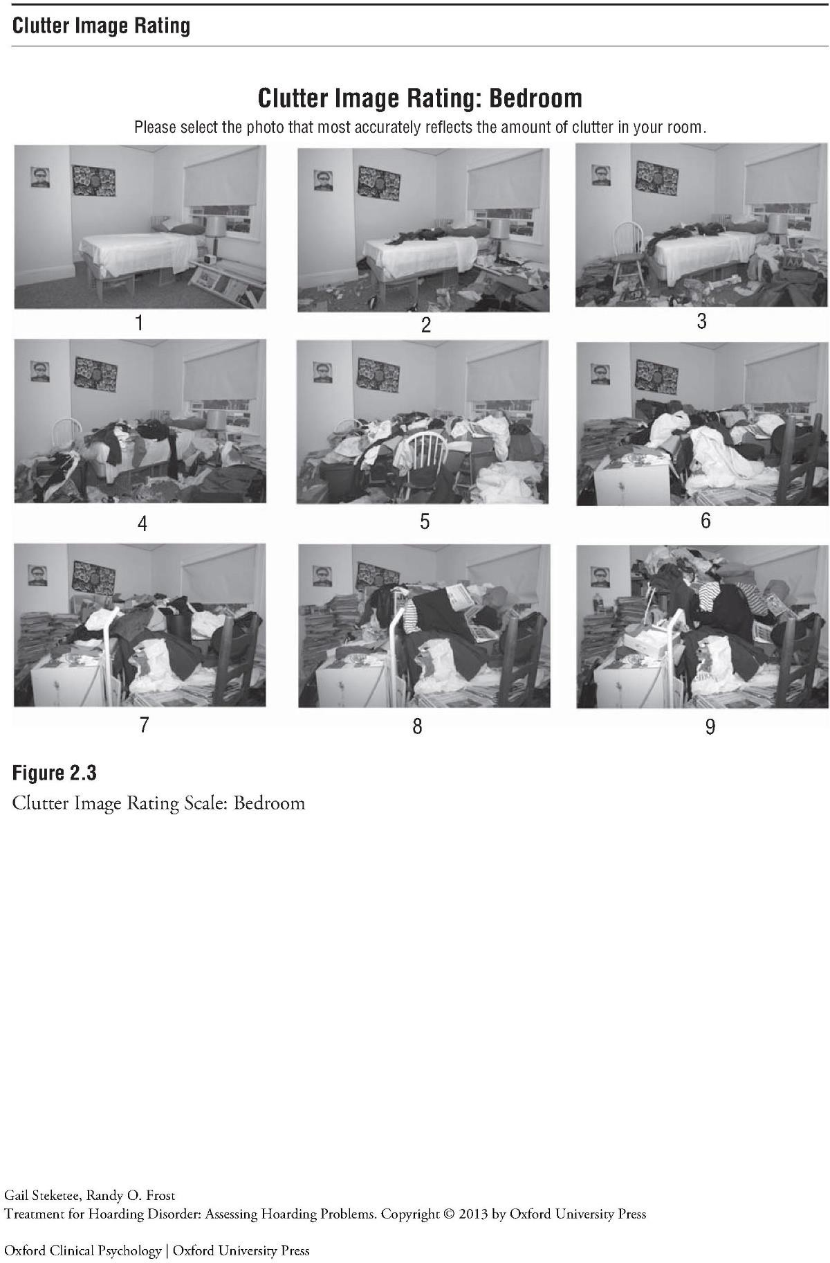

Clutter rating guidance/descriptors

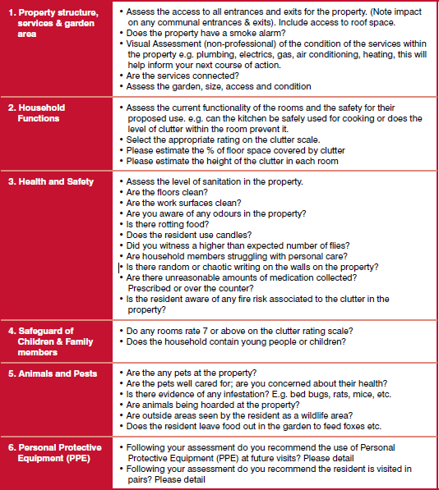

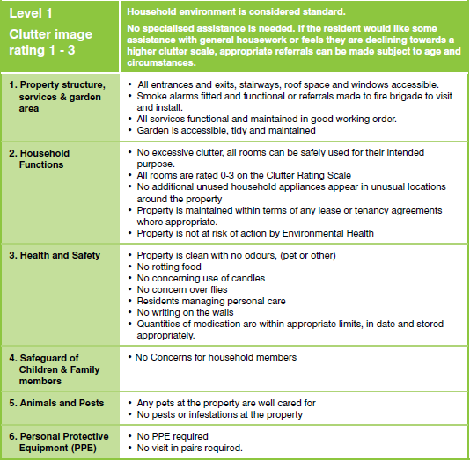

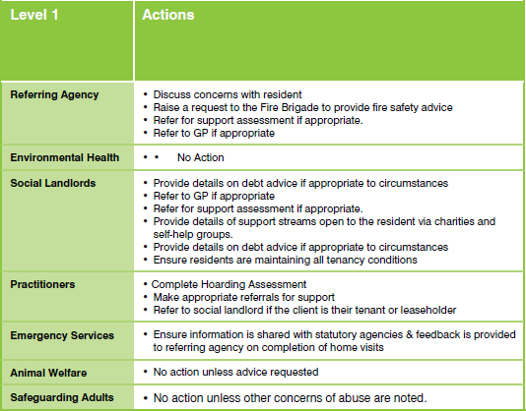

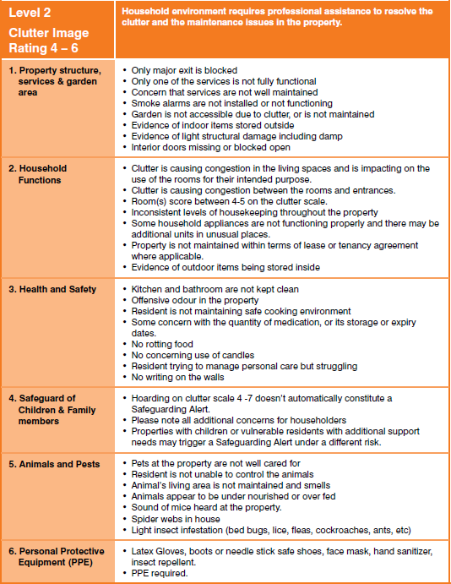

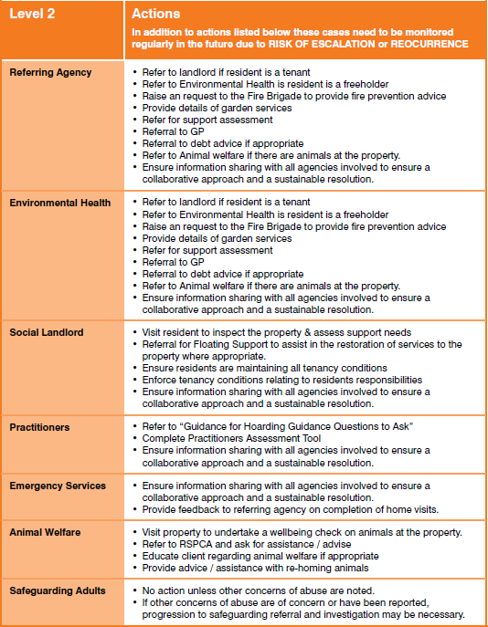

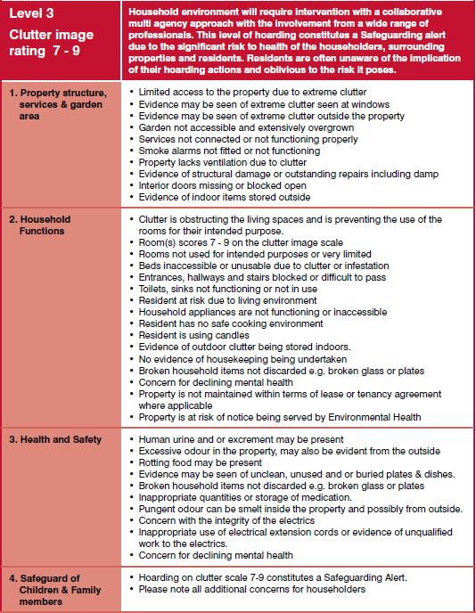

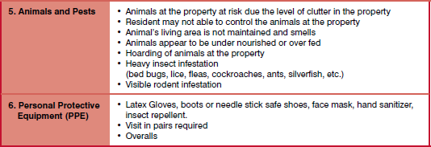

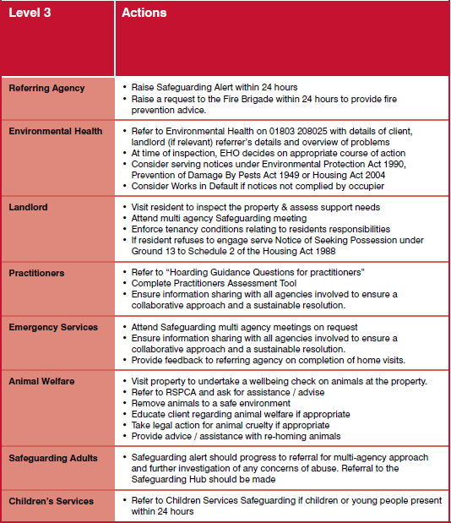

Appendix 1: Reading Borough Council referral for Multi - Agency Meeting self- neglect and hoarding

Client’s name: Date of home visit:
Client’s DOB: Client’s Address:
Telephone number:
Type and tenure of home:
Household members: Relationship:
Are there any children living at the premises? Yes ☐ No ☐
If yes,

Name and DOB:
Are they known to or has a referral been made to Brighter Futures for Children? Yes☐ No☐
NOK / Advocate / friend contact and relationship to client

Name: Telephone Number:
Email address: Relationship to client:
Is a referral for advocacy required? Yes☐ No☐
Are pets present? Yes☐ No☐
List other agencies / professionals involved:
Risks
Structural issues:
Insect / rodent infestation:

Human / animal waste:
Blocked exits:

Stairway access:
Hearing / sight impairment:
Risks to others? i.e., neighbours/ children:
Fire risks – including flammable material (i.e., newspapers), use of oxygen, emollient cream, smoker, alcohol, drug misuse.
Ability to leave building in case of fire.
Has there been a capacity assessment? Yes☐ No☐ If not, indication of capacity and description:
Known mental health issues / diagnosis:
Dementia diagnosis:
Physical health issues including impact on mobility:
Financial situation / ability to fund services:
Clutter rating by room – indicate by level number using CRT (T6)
Hallway: Living room: Bedroom 1:
Kitchen: Bathroom: Bedroom 2: External space:
Describe any concerns regarding garden or vehicles or outhouses:

Additional comments/ descriptors:
Practitioner’s details
Name: Email: Signature:
Consent to share by service user: Yes ☐ No☐
If no, is this information being shared under Berkshire Safeguarding Protocol?

Yes ☐ No ☐
Service User’s Views

Describe your concerns:
What outcomes would you like?
Comments:
Referral to or current involvement with other agencies (tick as appropriate):
Adult Social Care ☐ | Mental Health Team ☐
GP/ Community Nurse ☐ | Children’s Services ☐
RSPCA ☐  Association)/ landlord) ☐ | Housing (LA (Local Authority)/ HA (Housing

Voluntary sector ☐ – specify:

Appendix 2: Multidisciplinary Strategy Meeting Minutes

Date  Time |  |  | Venue
SECTION 1 - DETAILS OF PERSON
Name of person at risk |  |  |  |  |  |  | Mosaic/NHS  No.
Legal status (i.e., Court of Protection. Power of Attorney, Guardianship, etc):
Communication needs:
The person’s views/wishes in regard to this concern:
Capacity relating to this concern:
Family information / Significant others
Name |  |  |  |  | Contact information |  |  | Relationship to person
SECTION 2 - ATTENDANCE AT MEETING
Chair |  |  |  |  |  | Designation and agency
Attendees
Apologies
SECTION 3 - BACKGROUND TO REFFERAL

SECTION 4 – RISKS
SECTION 5 - WHAT WAS DISCUSSED AT THIS MEETING

SECTION 6 - ASSESSMENT OF RISK AND PLAN
Risk | Person’s views | Plan | Remaining Risk |  | Contingency Plan
SECTION 7 – IMMEDIATE ACTIONS REQUIRED
Who will take these actions and by when: |  |  |  | Yes/No

SIGNATURES:

Name (Print) |  | Signature | Tel. No. | Email
Form Completed By
Name:
Title:
Agency:

Appendix 3: Safeguarding consultation document (case closure)

Safeguarding Consultation Document

Date
Time
Attendees
Name of Service User

Brief History
Discussion
Actions/Analysis of continuing risk and protective factors in place
Follow up meeting date | .
Signed

Appendix 4: Ice breaker to be used by individuals to talk to health (or other) professionals

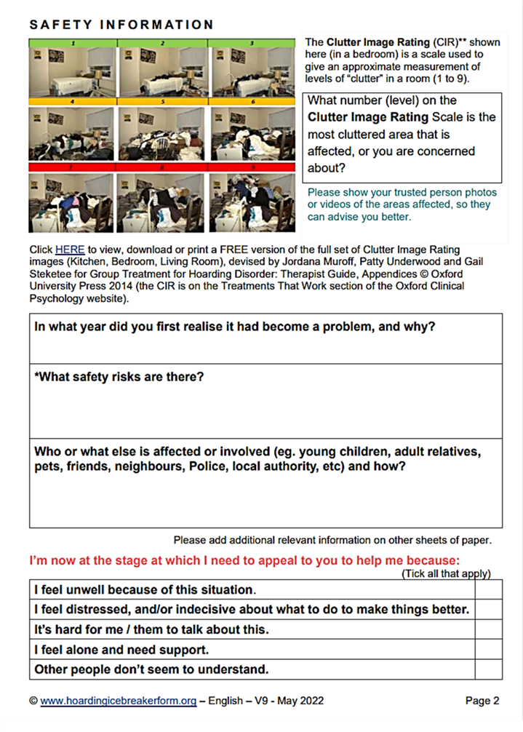

Appendix 5: Guidance Questions for Practitioners

Listed below are examples of questions you could ask, where you are concerned about someone’s safety in their own home, where you suspect a risk of self- neglect and hoarding.
Most clients with a hoarding problem will be embarrassed about their surroundings so adapt the question where needed,
- How do you get in and out of your property, do you feel safe living here?
- Have you ever had an accident, slipped, tripped up or fallen? How did it happen?
- How have you made your home safer to prevent this from happening?
- How do move safely around your home (where the floor is uneven or covered, or there are exposed wires, damp, rot, or other hazards)
- Has a fire ever started by accident?
- How do you get hot water, lighting, heating? Do these services work properly?
- Have they ever been tested?
- Do you ever use candles or an open flame to heat and light here or cook with camping gas?
- How do you manage to keep yourself warm? Especially in winter?
- When did you last go out in your garden? Do you feel safe to go out there?
- Are you worried about other people getting in your garden to try and break-in?
- Has this ever happened?
- Are you worried about mice, rats or foxes, or other pests? Do you leave food out for them?
- Have you ever seen mice or rats in your home? Have they eaten any of your food?
- Can you prepare food, cook, and wash up in your kitchen?
- Do you use your fridge? Can I have look in it? How do you keep things cold in the hot weather?
- How do you keep yourself clean? Can I see your bathroom? Are you able to use your bathroom and the toilet, ok? Have a wash, bath? Shower?
- Can you show me where you sleep and let me see your upstairs rooms?
- Are the stairs safe to walk up? (If there are any)
- What do you do with your dirty washing?
- Where do you sleep? Are you able to change your bed linen regularly?
- How do you keep yourself warm at night?
- Have you got extra coverings to put on your bed if you are cold?
- Are there any broken windows in your home? Any repairs that need to be done?
- Because of the number of possessions you have, do you find it difficult to use some of your rooms? If so which ones?
- Do you struggle with discarding things or to what extent do you have difficulty discarding (or recycling, selling, giving away)?

Appendix 6: Readiness to Change Questionnaire/ Evaluation (self- assessment tool to be used with the individual)

 |  | Strongly Agree | Agree | Unsure | Disagree | Strongly Disagree
1 | My home is ok as it is
2 | I am trying to collect less than I used to
3 | I enjoy keeping things but sometimes I keep  too much
4 | I should cut down on my collecting
5 | It is a waste of time thinking about my  collecting
6 | I have just recently changed my collecting  habits
7 | Anyone can talk about wanting to do  something about collecting, but I am actually doing something about it
8 | I am at the stage where I should think about  collecting less
9 | My collecting is a problem
10 | It is alright for me to keep collecting as I do  now
11 | I am actually changing my collecting habits  right now
12 | My life would be the same, even if I  collected less

How to score the Stage of Change questionnaire:
- The pre-contemplation questions are numbers 1, 5, 10 and 12
- The contemplation questions are numbers 3, 4, 8, and 9
- The questions indicating action are 2, 6, 7

Appendix 7: Residents who do not engage with Social Care

Reading Borough Council
Directorate of Adult Social Care and Health Operational Guidance - Residents who do not engage with Social Care
Effective date 16th June 2022 Version: 1.3
Background
Statutory agencies that are responsible for supporting adults who may be described as vulnerable and often have the difficult task of trying to engage with people who choose not to accept offers of advice and support regardless of risk to their own health and wellbeing.
Quite often these people have complex needs or presenting behaviours and are difficult to engage, and this can cause difficulties in planning and implementing appropriate support plans to their particular situations, where Care Act duties in relation to safeguarding have been considered and excluded.
The guidance provides a framework for operational staff and managers on how the needs or presenting issues of this group of people should be addressed. This guidance advocates a multi-agency approach as the most appropriate model for achieving engagement with adult’s not willing to engage and agreeing a support plan for delivering the agreed actions to achieve the best outcomes.
This guidance only relates to adults who have mental capacity to make decisions about their support/living arrangements but choose not to engage with offers of information advice or support. Guidance to working with adults who do not have capacity and are difficult to engage with is incorporated in the adult safeguarding procedures, Reading Branch (berkshiresafeguardingadults.co.uk).
This guidance should be read as a complementary supporting document to the Berkshire Adult Safeguarding Practice manual. Whilst there will be times when the presenting situation pertaining to an individual who is at risk does not fall within the remit of the Adult Safeguarding procedures, the principles of how risks are monitored and managed should mirror best practice in relation to Adult Safeguarding.
Consideration should be given to (MARM) Multiagency Risk Management process and if in doubt a discussion with you Team Manager or a Senior Manager can guide you to whether or not action needs to be taken in line with the Safeguarding framework to manage the situation/concerns.

Introduction
Users of health and social care services may choose to not to engage or disengage contact with a proportion of or all of the services provided. In the vast majority of cases this is not problematic; however, there will be occasions when this situation may give cause for concern.

It is recognised that for some service users there could be issues of risk if they do not engage with an assessment or review.
It is recognised that the nature of non-engagement with services is extremely complex and there may be a number of reasons why an individual may not engage or attend services.
These may include:
  - A lack of information relating to their referral or the type of help available
  - Poor relationship, lack of trust between the service user and Council or Social Care team
  - A lack of recognition on the part of the service user of the benefits that the care and support may offer
  - A culturally inappropriate response which does not reflect or take into account the lifestyle, beliefs, financial needs, and position of the service user
  - A person may be subject to coercion and control from another person.
  - Lack of consent obtained from the service user, or service user not being informed of the referral
This practice guidance note sets out a pragmatic guide to assist social care personnel in providing safe and appropriate care for difficult to engage service users and /or a response to those who do not attend an appointment.
The reasons for monitoring and managing service users who are difficult to engage are to minimise the risk they could present to themselves or others. It is a principle of good practice that attempts should be made to engage or reengage those who do not attend or disengage from care services.
Difficult to engage service users would include those where there is a history of disengagement from services and sufficient risk to self or others to negate the option of case closure. Those who have not received proposed intervention due to poor engagements. A multidisciplinary Planning Meeting can be a helpful process to address the issues as case records should not remain open without active engagement, clearly defined monitoring, or intervention.
  - Non-attendance would include:
  - not attending for the initial assessment interview
  - not attending for a subsequent appointment
  - not being at home when visited by a member of staff when the date and time of the visit has been pre-arranged
  - not attending Day Services on one or more occasion
  - having moved from a usual place of residence and having given no indication of a new address

New Referral
Where new referrals did not engage or attend a meeting, in addition to considering further action (below):
- a telephone contact with next of kin or relative on file
- a letter to service user on how they can contact the service and

- a letter should be sent to the General Practitioner (GP) within five working days.
- Letter to the referrer within five working days.

It is also worth checking that address details are correct both on file and on any letters sent.
Action to take when service users do not engage an appointment will be dependent on the level of risk. If the referral letter suggests high risk, then there should be liaison with the GP and/or referrer as soon as possible to establish the best plan to engage the service user or protect whoever is at risk (the service user or others).
Service users should always be given further chances to engage, and consideration should be given as to the most appropriate response such as:
Ring GP or other referrer to obtain further information/discuss /when they have last seen or heard from the individual, had they made the individual aware of the referral /did they obtain their consent?
  - Ring service user / carer to discuss
  - Send service user / carer a further appointment
  - Send a letter asking the service user / carer to get in touch within 2 weeks if they would like another appointment – copy to the GP?
  - Discuss with others involved in care, and /or the Multi-Disciplinary Team (MDT)
  - Arrange home visit.
  - Convene a multi-agency meeting to examine options.
  - Request a Welfare Check
  - Consider referral to mental health services such as, Gateway, Crisis Resolution Home Treatment Team, Home Treatment Team as appropriate if the individual has relapsed in mental health
  - Arrange Mental Health Act assessment if indicated.
It is important not to assume that the service user is not interested in involvement, but that there may be valid barriers to engagement which require help to overcome. Attempts to discover such barriers would be appropriate as above.
Any response will be dependent on the level of risk. If the referral letter suggests high risk, then there should be liaison with the GP/referrer as soon as possible to establish the best plan to engage the service user or protect whoever is at risk (the service user or others). The practitioner must also consider whether there have been previous referrals, the timing and nature of those referrals and what engagement was achieved I.e., Checking chronology on the system
All actions and reasons must be recorded with time and date in the service user’s records.
If you feel an unannounced visit is necessary as the first contact, document your risk analysis and reason you would not seek initial consent via another contact method. Best practice would be to always phone the person first. If there is a voicemail facility, leave a voicemail if you are sure that the voicemail belongs to the person you are calling, even then leave a general message, your name and call centre phone number- say calling from RBC (Reading Borough Council) Adult Social Care. Try again shortly after as many people do not answer concealed numbers.

If no response, call again later in the day or the next day, maybe a different time of day - same as above.
If no response.
Triage risk again, review connected care and check contact numbers and any additional risks not identified in the referral- send a letter or an email (use team email address, if possible, in case you are away when they reply). Use text if you assess this is safe to do so
- work mobile, be prepared to set boundaries around contact.
If still no contact speak to the referrer for more information, check that the person consented to the referral? Have they seen the person, has the person changed their mind, could a joint visit help facilitate engagement?
If there is no consent and you cannot contact them on the phone and the referrer cannot help and they have not responded to a letter and no risk indicators to suggest something else, then you may decide to stop there and close the case. Document your rationale. Let GP know and referrer if appropriate.
You might decide risk warrants an attempt at a visit- send an appointment by post- visit at the arranged time.
If you think it is necessary to do an urgent visit/unannounced you need to document why this is necessary and proportionate without prior consent- it could be on the basis of risk or relapse, previous history, safeguarding concern, has not seen the GP for some time, has discontinued medication, concerns about self-neglect.
If you still cannot get access- look for signs of self-neglect/neglect at the property, activity at the property. Depending on what you find options to consider: leaving a note through the door to call you and try again.
Where there are issues of Hoarding, Substance Misuse and /or mental health (not open to NHS services). Practitioners should consider multi-agency risk management plans as a result of any MDT meetings.
You may decide that to write to the person to tell them how to contact us if they decide they want to and close, inform the referrer if it is appropriate to.
If very concerned may be refer for
  - a police welfare check
  - mental health services Gateway, Crisis Resolution Home Treatment Team, Home Treatment Team as appropriate, Drug and Alcohol Services (CGL) or
  - a mental health act assessment if there is evidence of mental disorder and relapse and risk that cannot be mitigated by the interventions from the mental health services, or
  - a referral to Environmental Control / Fire Service.
If the person is disengaging after a period of engagement- explain the basis they are doing this in your records and the options you have considered (mental capacity, mental or physical health relapse, exploitation, coercion).

Service Users who are reluctant to engage or who have disengaged

Every effort must be made to engage with service users whilst they are in need of services. Appointment reminders can promote attendance and can be in the form of letters, phone calls, text messages or e-mails as appropriate and bearing in mind confidentiality issues.
When a service user chooses not to engage with services, every effort must be made to find out why and the reasons given recorded in the service users notes. Social Care staff’s skill, knowledge and experience need to be utilised in dealing with what is a challenging situation, both for the service user, relatives, and staff alike. Every effort must be made to put the service user at ease and discuss with them the concerns and reasons why they do not want to engage with services.
A review meeting can be called where necessary to determine the reasons for disengagement or non-attendance and to see whether any changes can be made to the support plan in order to re-engage the service user. The above options should be considered, however, where the situation warrants prompt intervention, welfare check or an assessment under the Mental Capacity Act or Mental Health Act 1983 should be considered.
Should these strategies prove unsuccessful, the following approaches to facilitate engagement and management of risk should be considered:
  - Who is to visit/contact and how often
  - Communication plan between all involved agencies and parties - this can be agreed at a Multiagency Planning Meeting
  - Involvement of immediate and wider family
  - Consideration of involvement of police and/or other agencies
  - Consideration of involvement of statutory mechanisms
  - Plan review with multidisciplinary team
Where appropriate, social care services should be asked to try and engage service users perhaps by further assessment or, if appropriate, by involving family.
If the action plan to engage the service user fails, further discussion with MDT may conclude that the service user’s needs are best met by other defined agencies.
Consideration must be given to the degree of concern and the level of risk posed. An action plan to manage identified risks should be agreed with a manager/supervisor and will include specific indications for re-referral. If the service user does not have a GP, then straightforward arrangements should be made so he/she can self-refer.
Service Users not registered with a GP
Service users who are not registered with a GP should be encouraged to register. If this is not possible the practitioner should facilitate the service user in contacting the Integrated Care System (ICS) so that a GP practice is allocated to the service user.
Summary/Advice
This is not an exhaustive list of actions however the most important issue is to ensure that every effort is made to enable engagement alongside Multidisciplinary Planning Meetings chaired by a Team Manager or more Senior Manager and that every attempt is recorded including the date and time and that other professionals are contacted and engaged to asset as required. This Guidance does not negate any duties upon us, or our duty of care as laid down in the legislation Care Act 2014 – Care & Support Guidance Refusal of Assessment 6.20, Mental Capacity Act 2005, Mental Health Act 1983 revised 2007, or any other

legislation government guidance. Ensure that discussions with Managers are also recorded on the case file and dated and timed.

Appendix 8: Information sharing policy/guidance

Ensure all information sharing is in line with Berkshire Safeguarding Adults Boards’
Information Sharing Protocol
pan-berkshire-sab-information-sharing-protocol-v10.pdf (sabberkshirewest.co.uk)
pan-berkshire-sab-in formation-sharing-pr

Appendix 9: Local Organisations / Resources

Hoarding and Self Protocols - Useful Co
USEFUL CONTACTS

References/ Acknowledgements
Jo Cooke – Hoarding Disorders UK, have been invaluable in their support – providing training, advice and linking with other local authorities who are also considering the best way to provide services to this group of residents.
Reference to other local authority protocols – Wokingham, Slough, Lincolnshire, Islington, Swindon, Torbay
Colleagues in the local voluntary sector and within RBC West Berks Safeguarding Adults Board https://www.ncbi.nlm.nih.gov/pmc/articles/PMC4396642/ The International OCD Foundation - study by Frost RO, Steketee G, Tolin DF, Renaud S. Development and validation of the Clutter Image Rating. Journal of Psychopathology and Behavioral Assessment. 2008;32:401–417’
Cherry Rudge at Rainbow Red.

