Clean Air Act 1993
Section 18
THE READING BOROUGH COUNCIL SMOKE CONTROL ORDER 2023
Reading Borough Council (“the Council”) of Civic Offices, Bridge Street, Reading, RG1 2LU has made the following Order, in the exercise of its powers under Section 18 of the Clean Air Act 1993:

1 This Order may be cited as ‘the Reading Borough Council Smoke Control Order 2023’. It will come into operation on [a date not less than six months after this Order is confirmed by the Secretary of State] 2023/2024.
2 The Council declares the whole of the area within its boundary to be a Smoke Control Area (‘The Smoke Control Area’). The extent of the Smoke Control Area is shown on the plan annexed at schedule 1 to this Order.
Draft
3. All the existing Smoke Control Orders listed in Schedule 2 to this Order are hereby revoked, insofar as they apply to the area of the Borough of Reading from the date that this Order comes into operation.

4. In the whole of the Smoke Control Area created by this Order (that is, all land within the borough boundary), the operation of section 19A and Schedule 1A of the Clean Air Act 1993 (Penalty for emission of smoke in smoke control area in England) shall be applicable to all buildings.

5. Other than exemptions made by the Secretary of State under section 19C and section 19D of the Act, there are no buildings, or classes of buildings, or fireplaces, or classes of fireplaces in the Smoke Control Area that are exempt from the operation of section 19A and Schedule 1A of the Clean Air Act 1993 (Penalty for emission of smoke in a smoke control area in England).

[seal of the Borough Council]

Director of Public Health

[signature of the proper officer of the Council]

SCHEDULE 1
PLAN OF READING BOROUGH COUNCIL SMOKE CONTROL AREA 2023
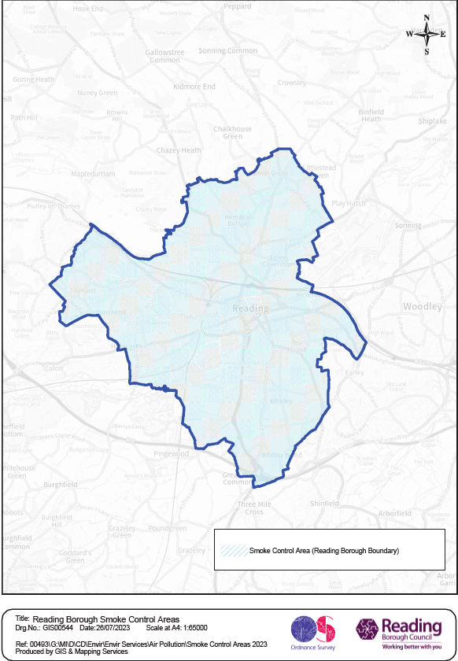
SCHEDULE 2
LIST OF SMOKE CONTROL ORDERS REVOKED

Coley Park Smoke Control Order 1 June 1959,
Broad Street/Friar Street Smoke Control Order 1 June 1960,
Coley Park Extension, Smoke Control Order 1 December 1961,
Burghfield Road Smoke Control Order, 1 November 1961,
Old Southcote Lodge Smoke Control Order, 1 November 1961,
Broad Street/Mill Lane Smoke Control Order, 1 November 1961,
Burghfield Road/Holybrook Crescent Smoke Control Order, 1 November 1961,
Cockney Hill/Prospect Park Smoke Control Order, 1 November 1963,
Southcote Smoke Control Order, 1 November 1965,
Bath road Smoke Control Order, 1 November 1966,
Tilehurst Smoke Control Order, 1968,
Draft
Friar Street Smoke Control Order, 1969,
Norcot Smoke Control Order, 1 September 1970,
EST Reading/Abbey Ward Smoke Control Order, 1 September 1971,
Newtown Smoke Control Order, 1 September 1972,
Dee Road, Smoke Control Order, 1 September 1972,
Kentwood Smoke Control Order, 1 November 1972,
Castle/Coley Smoke Control Order, 1 September 1973,
West Reading Smoke Control Order, 1 November 1974,
Lower Caversham Smoke Control Order, 1 November 1974,
Whitley Rise/Basingstoke Road Smoke Control Order, 1 July 1975.

