Step by Step
Supplier Guide
to
Reading Borough Council
e-Tendering System

Introduction

This Step-By-Step Guide is provided to assist you in using the (In-tend) e-tendering system. Once you have registered, you will be able to maintain your company information, return tender submissions and maintain company/contract documentation in a secure area via the internet.

If you encounter any difficulties whilst using the system you can contact out Support team by phoning 0844 2728810 or emailing support@in-tend.co.uk

Registering on the e-Tendering system

Visit https://in-tendhost.co.uk/readingbc to access the (In-tend) supplier portal.

From the homepage click on Register

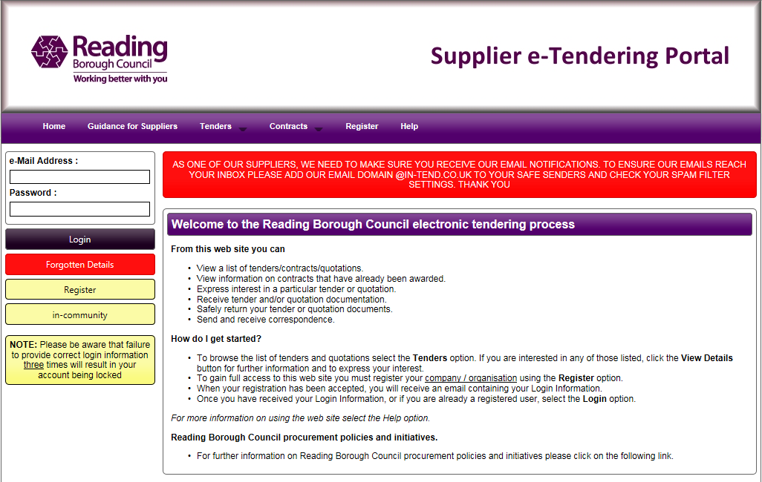

Registration process
As part of the simple registration form you will be asked to complete your Company Details, Company Contact Details and Primary User Details. Email alerts and actions will be sent to the email addresses you provide, so if possible it is useful to enter a general company email address in the Primary User Details section such as info@ *****.co.uk.
For cases where this person or inbox may be unavailable, we strongly recommended you add an Additional User (located at the bottom of the screen) so they can gain access to the site and also receive a copy of the emails. All Yellow fields are mandatory
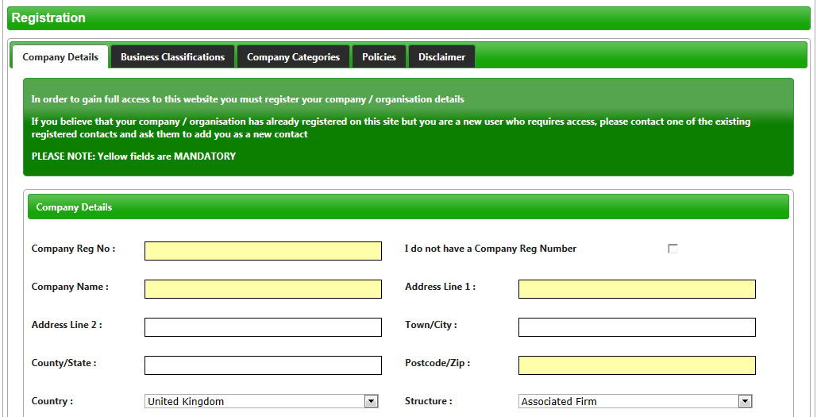
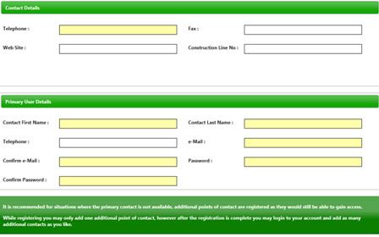

Whilst registering you may only add one additional point of contact, however after the registration is complete you may login to your account and add as many additional contacts as you like.
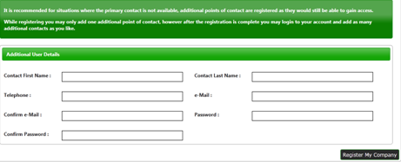
In the Business Classifications tab you are able to add the business category codes relevant to your company. Enter a keyword or click on the search button to see the full list of available categories. Click the blue + symbol to add a category you require. You can add multiple categories.
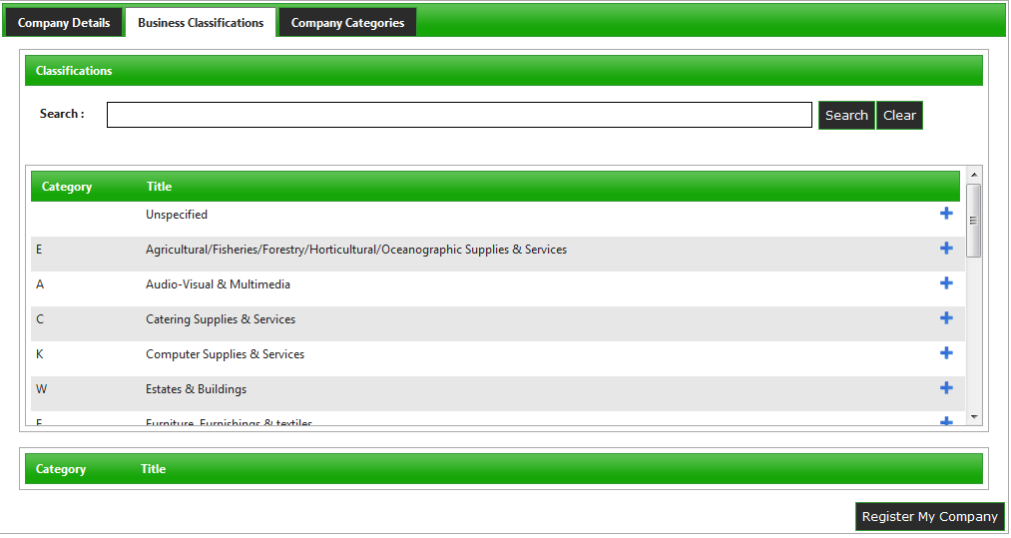

In the Company Categories tab you are able to tick any of the categories that apply to your company.
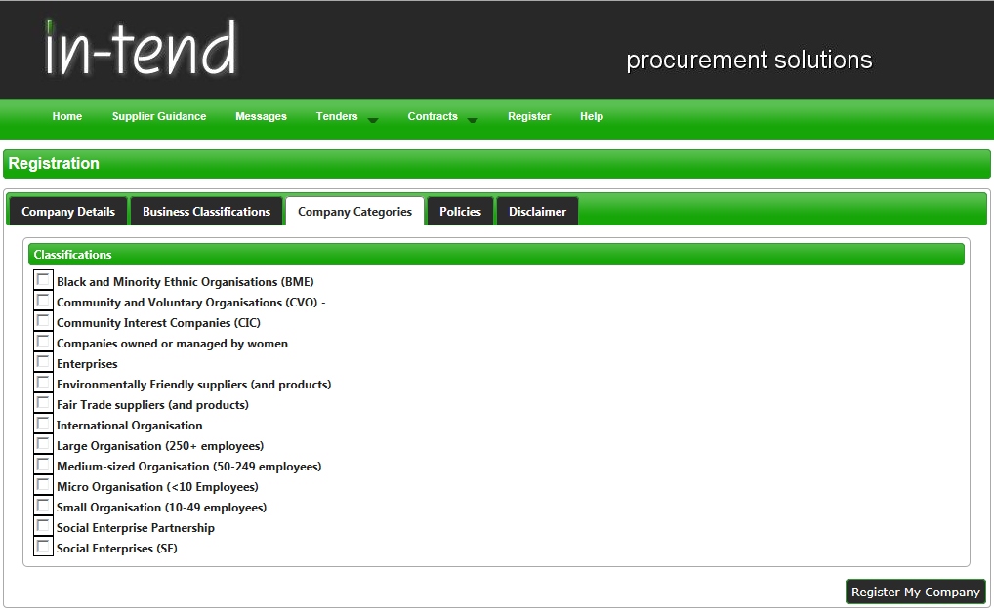

In the Policies tab you are able to tick any of the listed polices that your company currently holds
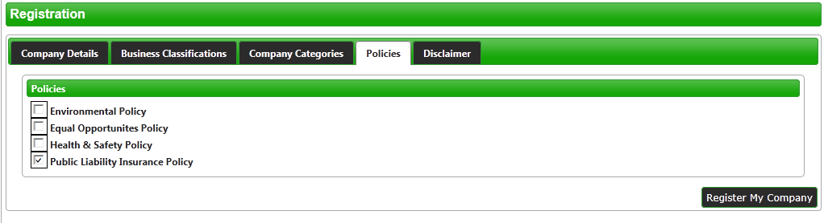

Once you are happy with the details click on Register My Company

You should not register your company more than once, unless they are under a separate company registration number. If your company has several locations, register the company against the head office and add contact details for individuals at the different locations. You can add one additional user at the time of registration. Once registered, you can add several contacts in the Company Details section.

Once registration is complete, the system will then thank you for registering and inform you that your details are being processed. You will then shortly receive an email with confirmation of your email and password.

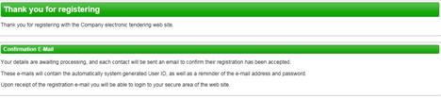

Managing your Company Details
If you need to update your company information you can do this from the Company Details section on the top menu bar. From here you can edit/add information regarding the company, contact details, company documents and business classifications.
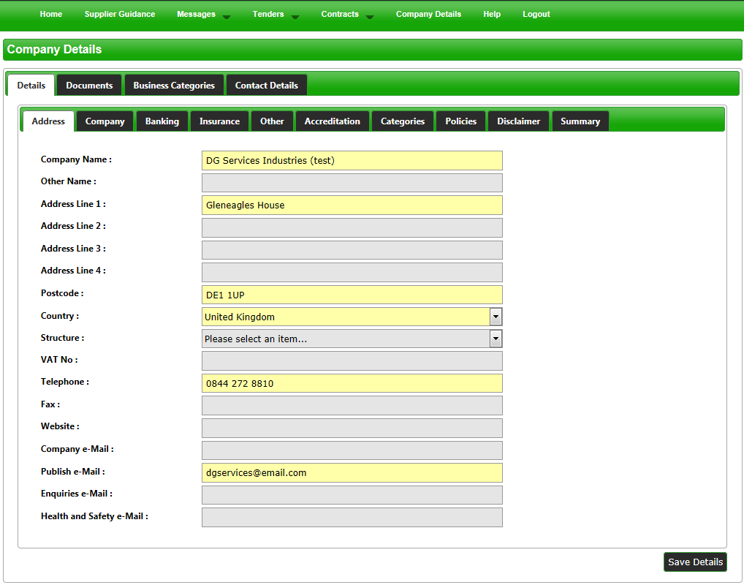

Please note that it is important that you do keep your details up to date, particularly your contact email addresses as you may miss out on tender opportunities which may be of interest.

