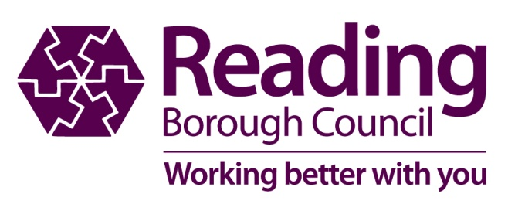

Michael Graham

Electoral Registration Officer/Returning Officer

Civic Centre

Reading

Berkshire

RG1 2LU

🕿0118 937 3717

**Ask for:** Electoral Services

**Direct:** 🕿 0118 937 3717

**e-mail:** [polling.review@reading.gov.uk](mailto:polling.review@reading.gov.uk)

**Date:** 1st November 2023

|  |  |
| --- | --- |
| Your contact is: | Electoral Services Manager - [polling.review@reading.gov.uk](mailto:polling.review@reading.gov.uk) |

## Reading - Review of Polling Districts and Polling Places 2023/24

I am writing to you to let you know that the Council – along with all other local authorities in England – is carrying out a review of the polling districts and polling places in the Borough. We are doing this under the provisions of Section 18C of the Representation of the People Act 1983.

Earlier this year the Boundary Commission for England (BCRE) an independent and impartial public organisation reviewed the Parliamentary Constituency Boundaries in England. The recommended changes will see three Parliamentary Constituencies Reading Central (administered by Acting Returning Officer provided by Reading Borough Council), Earley and Woodley (administered by the Acting Returning Officer provided by Wokingham Borough Council) and Reading West/Mid Berkshire County (administered by the Acting Returning Officer provided by West Berkshire District Council). Currently the borough is covered by Reading East and Reading West Constituences and the Acting Returning Officer for both these constituencies is provided by Reading Bororugh Council.

The review must be concluded by March 2024. The process is based on parliamentary constituencies, with the Council’s specific interest in the arrangements that it makes within the Borough boundaries. As Acting Returning Officer for the Reading East and Reading West constituencies I am empowered to make comments to West Berkshire and Wokingham in respect of the arrangements that they make for polling districts and places in their parts of the two Reading constituencies.

Under Schedule A1 of the Parliamentary Election Rules the review involves a number of specified stages, which start with the publication of a notice of the review: this occurred on 1st November 2023, and the notice is now on display in the Civic Offices, at Reading Libraries, and on the Council’s website. Follow this link:

[www.reading.gov.uk/pollingplacesreview2023](http://www.reading.gov.uk/pollingplacesreview2023)

As part of the review, any elector may make representations, which may include comments on current polling district boundaries and proposals for specified alternative polling places. In addition, comments are invited on the facilities for access to polling stations, and the Council will be consulting directly with persons with an expertise in relation to access and disability.

I enclose a copy of the notice and accompanying maps. Comments are invited by **1st December 2023.** If you wish to make any representations you should do so in writing to the Electoral Services Manager by that date, by letter, or by e-mail, or through the Council’s website, using the contact points quoted in the attached notice. Please note that the Regulations governing the review require me to publish all representations I receive and personal data will be removed upon publication.

On completion of the review, the Council must compile and adopt a revised scheme, which it must publish, with reasons given for its decisions. The intention is that this will be adopted by full Council on 19th March 2023, in order that the new electoral register, to be published on 1 December 2023, is based on the revised scheme.

Please feel free to pass on this request to any other person who you consider might find it of interest, and I look forward to receiving any representations you might wish to make by 1st December 2023.

Yours faithfully



Michael Graham

Electoral Registration Officer and Returning Officer