Network North highway maintenance reporting
‘Made possible by reallocated HS2 funding’
The Department of Transport requires all Local Highway Authorities to publish on their websites a plan for the additional resurfacing and other highways maintenance work that they will deliver with the new 2023/24 and 2024/25 funding unlocked from the Network North plan.
The Council’s Medium Term Financial Strategy is informed by and supports delivery of the Council’s Corporate Plan priorities including its commitment to address the climate change emergency and seeks to ensure that the Council is “fit for the future”, with sound finances that allow the Council’s future funding challenges and spending pressures to be met in as sustainable a way as possible.
The underpinning rationale of the Medium-Term Financial Strategy is to deliver a balanced and affordable budget that ensures the Council’s finances are sustainable in both the short (one year) and medium term (three years). The Strategy is also informed by the Council’s Vision: “to ensure that Reading realises its potential – and that everyone who lives and works in Reading can share in the benefits of its success”, as well as its Corporate Plan priorities:
• Securing the economic success of Reading;
• Improving access to decent housing to meet local needs;
• Protecting and enhancing the life outcomes of vulnerable adults and children;
The Strategy builds on work over the previous 5-6 years to stabilise the Council’s financial position and build reserves back to a more robust level and seeks to facilitate vital investment in core infrastructure to drive efficiency improvements, facilitate service redesign and thereby manage pressures within demand led services. This ‘invest to save’ approach provides for a robust financial position going forward and enables vital and valued services can continue to be delivered.
As part of MTFS an ambitious capital investment programme is being delivered with the Council investing £8M (over 5-years from 2022/23 to 2026/27) in Reading’s local residential road and pavement network. This welcomed Council investment is over and above the annual Local Transport Block Funding Grant settlement of £1.838M from the DfT for Bridges & Carriageways, the additional DfT Road Resurfacing Fund 11-Year Allocation for Reading of £7.726M and follows on from the successfully delivered £9M Council investment in Residential Roads & Pavements between 2020/21 to 2022/23, which continues improving the condition of local residential roads and pavements and reverses a deteriorating highway network.
The DfT announced additional funding of £7.726M over 11-years (2023/24 to 2033/34) to be allocated to Reading as part of the Network North Highway Maintenance re-allocation.
£232k has to be committed within the current Financial Year (2023/24) and £ 232k in 2024/25. The remaining £ 7.262M to be split over the financial years 2024/25 to 2033/34.
The following link will take you to the Council’s Committee Report detailing the spend proposal for Capital schemes for the DfT Network North funding award for both 2023/24 and 2024/25, which will assist Reading with further improving our strategic major roads.
Agenda for Housing, Neighbourhoods and Leisure Committee on Wednesday, 21st February, 2024, 6.30 pm - Reading Borough Council (refer to item 7 Highway Maintenance Update 2023-24 & Programme 2024-24 Committee report and 7b Appendix 2 – Highway Maintenance Works Programme 2024-25).
This valuable and very much appreciated additional DfT Network North £ 1.19M funding award for 2023/24 and 2024/25 will enable the Council to resurface an additional 23 sections of strategic major road carriageway and further improve our highway network, reduce the formation of potholes, reduce resident contacts relating to road condition and improve ride quality.
The Council will deliver the 23 additional schemes during 2024/25 financial year and before the end of March 2025.
The DfT Network North Funding will allow the Council to target its own Residential Minor (unclassified) Road Surfacing Investment Capital programme to further improve on what has been completed to date with 80% of residential local unclassified roads now showing as ‘Green Good Condition’. All communities within Reading will benefit from this investment, as well as from the Network North Additional Funding award.
The Council will report on the progress of these works at the next Housing Neighbourhood & Leisure Committee in June 2024, November 2024, and also at March 2025 Committee Meetings and publish the progress on the Council’s Website.
Innovation:
The Council are members of Local Council Road Innovation Group (LCRIG) and has a proud history of trialling innovation and adopting innovation as ‘business as usual’ to improve efficiency and reduce carbon to meet the Council’s ambitious 2030 Net Zero Carbon pledge, including the following recent Highway innovations that we now deploy across the highway maintenance programme:
- Meon fully electric road marking machine.
- Meon MMA cold applied road marking paint.
- Rolling out the iTip Handles with all Highways & Drainage Works Teams.
- Gaist Video Road Condition surveys for road surfacing selection.
- Deployment of Microsensors at Traffic Signal junctions to reduce the need of traffic loops.
- Meon footway preservation solution enabling our in-house works team to preserve and improve footways Boroughwide.
Recent innovation trials with suppliers include:
- Miles Macadam Biopave™Carbon Capture & Storage trial fortifying Miles Macadam’s Milepave™ grout with Biochar to permanently lock away carbon and cancel out the carbon cost of manufacture.
- Instaboom solar powered Stop / Go sign devices.
- Henry Williams new footway Rhinophalt Preservation machine.
- Solaris Lighting / Liveable Cities extension cable to reduce the need for a commando socket on a streetlight.
- Vaisala Winter Senor using LoRaWan Berkshire wide trials.
Adoption of lower carbon preservation techniques:
- Velocity delivering over 66,000m2 of Rhinophalt Preservation of the A33 between Junction 11 and Rose Kiln Lane North now to roll out on strategic routes.
- Planting over 315 trees on the public highway since 2022/23
The Council are committed to actively seeking innovation to drive efficiency, reduce carbon and incorporate new technology within standard maintenance delivery programmes. This ambition has resulted in the Highways & Traffic Manager being invited onto LCRIG Innovation Board, as recognition of the progress Reading Borough Council has made in delivering and trialling innovation.
Streetworks:
The Council recognises the importance of co-ordinating all activity on the public highway to reduce planned works programme clashes. The Council are committed to bringing a Street Works Permit system to Reading during 2024/25 to improve control, fine all overrunning activity and protect our highway network, which is the most valuable asset the Council has. The Resurfacing Team use Section 58 notices to protect new planned road resurfacing schemes and will issue these for the upcoming road resurfacing contract to protect this investment. In addition to this the Highways team plans all proposed works on the public highway with our Streetworks Team prior to tendering to ensure that we are aware of any upcoming utility works and can adjust our plans accordingly. Similarly we liaise with our Transport Planning and Development Control teams to avoid clashes with their works and known other planned schemes.
The spend over the last 5 financial years was as follows:
2019/20 £1.819M
2020/21 £1.9M
2021/22 £5.964M
2022/23 £3.034M
2023/24 £2.4M
2024/25 £3.75M
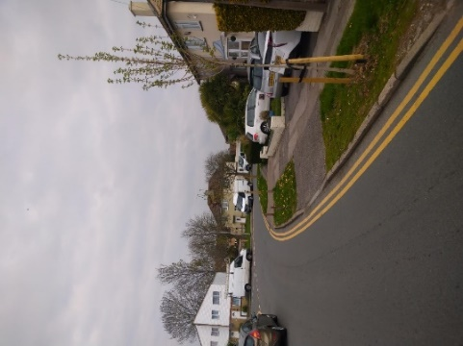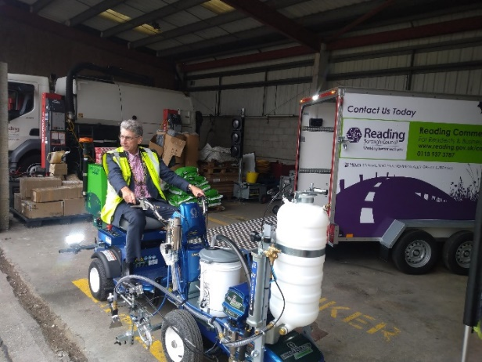
Tree Planting on Highway The Mayor Cllr Tony Page on the new Fully Electric Cold MMA Road Marking Machine.
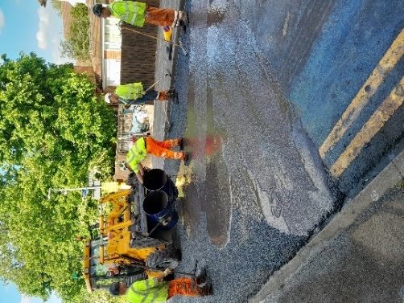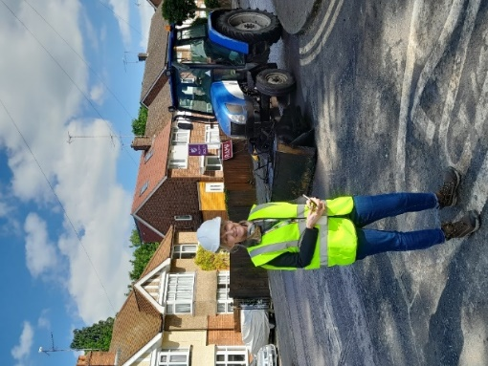
Miles Macadam Concrete Road trial Cllr Rowland in St Saviours Road

