**CENSUS 2021 – MIGRATION & DEMOGRAPHY**

Data from Census 2021 on the following topics is available:

* [Number of usual residents in households and communal establishments](https://www.nomisweb.co.uk/query/construct/summary.asp?mode=construct&version=0&dataset=2021)
* [Household size](https://www.nomisweb.co.uk/query/construct/summary.asp?mode=construct&version=0&dataset=2037)
* [Population density](https://www.nomisweb.co.uk/query/construct/summary.asp?mode=construct&version=0&dataset=2026)
* [Age and sex by single year](https://www.nomisweb.co.uk/query/construct/summary.asp?mode=construct&version=0&dataset=2027)
* [Household composition](https://www.nomisweb.co.uk/query/construct/summary.asp?mode=construct&version=0&dataset=2023)
* [Living arrangements](https://www.nomisweb.co.uk/query/construct/summary.asp?mode=construct&version=0&dataset=2030)
* [Legal partnership status](https://www.nomisweb.co.uk/query/construct/summary.asp?mode=construct&version=0&dataset=2022)
* [Households by deprivation dimensions](https://www.nomisweb.co.uk/query/construct/summary.asp?mode=construct&version=0&dataset=2031)
* [Country of birth](https://www.nomisweb.co.uk/query/construct/summary.asp?mode=construct&version=0&dataset=2024)
* [Passports held](https://www.nomisweb.co.uk/query/construct/summary.asp?mode=construct&version=0&dataset=2025)
* [Year of arrival in UK](https://www.nomisweb.co.uk/query/construct/summary.asp?mode=construct&version=0&dataset=2035)
* [Age of arrival in the UK](https://www.nomisweb.co.uk/query/construct/summary.asp?mode=construct&version=0&dataset=2038)
* [Length of residence](https://www.nomisweb.co.uk/query/construct/summary.asp?mode=construct&version=0&dataset=2036)
* [Migrant Indicator](https://www.nomisweb.co.uk/query/construct/summary.asp?mode=construct&version=0&dataset=2039)
* [Number of non-UK short-term residents by sex](https://www.nomisweb.co.uk/query/construct/summary.asp?mode=construct&version=0&dataset=2040)

The key data tables are shown below; data for all the variables in this topic can be found [here](https://www.ons.gov.uk/peoplepopulationandcommunity/populationandmigration/populationestimates/articles/demographyandmigrationdatacontent/2022-11-02#demography-household-characteristics).

Small area data down to Census Output Area level (areas of approx. 100-150 households) is available for each of the variables; interactive maps can be found [here](https://www.ons.gov.uk/census/maps):

Census data can also be accessed and analysed with the following tools:

* [Nomis - Official Census and Labour Market Statistics (nomisweb.co.uk)](https://www.nomisweb.co.uk/)
* [LG Inform Plus (esd.org.uk)](https://home.esd.org.uk/) (RBC is already a subscriber, you just need to register)

**Key headlines:**

* There has been an increase since 2011 of almost 8% in the proportion of residents born in other countries (to 36%), and in particular an increase in the proportion born in Romania (from 0.16% in 2011 to 1.9%) and India (from 3% in 2011 to 4.5%).
* The proportion of 50-64 year olds has increased, while the proportion of under 4s and 25-35 year olds has decreased since 2011.
* Reading has a relatively high number of singe residents (32%) compared with the national average (27%).
* Reading has a slightly higher % households deprived on all 4 dimensions (0.3%) than nationally (0.2%), but also a high % not deprived on any dimension (52% compared with 48% nationally). Fewer households are deprived than in 2011.

**COUNTRY OF BIRTH**

**Top ten**

|  |  |  |
| --- | --- | --- |
| ***Country*** | ***Count*** | ***%*** |
| England | 111,815 | 64.18% |
| India | 7,762 | 4.46% |
| Poland | 4,948 | 2.84% |
| Other Southern Asia | 4,224 | 2.42% |
| Pakistan | 3,546 | 2.04% |
| Romania | 3,231 | 1.85% |
| Other EU countries | 2,786 | 1.60% |
| Other Europe | 2,349 | 1.35% |
| Wales | 1,821 | 1.05% |
| Scotland | 1,659 | 0.95% |

**Full list**

| ***Country*** | ***Number*** | ***%*** | ***England*** | ***Reading 2011*** |
| --- | --- | --- | --- | --- |
| England | 111,815 | 64.18% | 80.35% | 72.06% |
| Northern Ireland | 587 | 0.34% | 0.34% | 0.45% |
| Scotland | 1,659 | 0.95% | 1.11% | 1.32% |
| Wales | 1,821 | 1.05% | 0.85% | 1.34% |
| Great Britain not otherwise specified | 1 | 0.00% | 0.00% | 0.00% |
| United Kingdom not otherwise specified | 11 | 0.01% | 0.00% | 0.02% |
| Ireland | 1,313 | 0.75% | 0.56% | n/a |
| France | 758 | 0.44% | 0.27% | 0.38% |
| Germany | 897 | 0.51% | 0.45% | 0.67% |
| Italy | 1,466 | 0.84% | 0.48% | 0.37% |
| Portugal (including Madeira and the Azores) | 1,105 | 0.63% | 0.27% | 0.34% |
| Spain (including Canary Islands) | 1,099 | 0.63% | 0.29% | 0.26% |
| Other member countries in March 2001 | 1,574 | 0.90% | 0.48% | 0.60% |
| Lithuania | 460 | 0.26% | 0.29% | 0.15% |
| Poland | 4,948 | 2.84% | 1.27% | 2.52% |
| Romania | 3,231 | 1.85% | 0.94% | 0.16% |
| Other EU countries | 2,786 | 1.60% | 0.97% | 0.90% |
| Croatia | 81 | 0.05% | 0.02% | n/a |
| Turkey | 606 | 0.35% | 0.22% | 0.15% |
| Other Europe | 2,349 | 1.35% | 0.65% | 0.67% |
| North Africa | 932 | 0.53% | 0.29% | 0.30% |
| Ghana | 1,439 | 0.83% | 0.23% | 0.52% |
| Nigeria | 954 | 0.55% | 0.47% | 0.48% |
| Other Central and Western Africa | 935 | 0.54% | 0.27% | 0.54% |
| Kenya | 613 | 0.35% | 0.24% | 0.41% |
| Somalia | 159 | 0.09% | 0.19% | 0.09% |
| South Africa | 1,067 | 0.61% | 0.37% | 0.53% |
| Zimbabwe | 758 | 0.44% | 0.21% | 0.53% |
| Other South and Eastern Africa | 1,212 | 0.70% | 0.47% | 0.90% |
| Africa not otherwise specified | 12 | 0.01% | 0.01% | 0.02% |
| Iran | 328 | 0.19% | 0.19% | 0.16% |
| Iraq | 112 | 0.06% | 0.15% | 0.43% |
| Other Middle East | 954 | 0.55% | 0.36% | 1.06% |
| China | 1,269 | 0.73% | 0.31% | 0.39% |
| Hong Kong (Special Administrative Region of China) | 1,330 | 0.76% | 0.21% | 0.50% |
| Other Eastern Asia | 286 | 0.16% | 0.12% | 0.17% |
| Afghanistan | 246 | 0.14% | 0.15% | n/a |
| India | 7,762 | 4.46% | 1.61% | 3.00% |
| Pakistan | 3,546 | 2.04% | 1.09% | 2.03% |
| Bangladesh | 521 | 0.30% | 0.47% | 0.23% |
| Sri Lanka | 497 | 0.29% | 0.25% | 0.27% |
| Other Southern Asia | 4,224 | 2.42% | 0.14% | 1.50% |
| Philippines | 759 | 0.44% | 0.26% | 0.40% |
| Malaysia | 329 | 0.19% | 0.11% | n/a |
| Singapore | 143 | 0.08% | 0.07% | n/a |
| Other South-East Asia | 649 | 0.37% | 0.23% | 0.59% |
| Central Asia | 126 | 0.07% | 0.02% | 0.06% |
| United States | 678 | 0.39% | 0.35% | 0.34% |
| Canada | 268 | 0.15% | 0.12% | n/a |
| Other North America | 11 | 0.01% | 0.01% | 0.19% |
| All Central American countries | 113 | 0.06% | 0.04% | 0.05% |
| All South American countries | 1,365 | 0.78% | 0.44% | 0.37% |
| Jamaica | 426 | 0.24% | 0.25% | 0.27% |
| Other Caribbean | 1,041 | 0.60% | 0.18% | 0.76% |
| Australia | 365 | 0.21% | 0.19% | 0.26% |
| New Zealand | 198 | 0.11% | 0.08% |  |
| Other Australasia | 1 | 0.00% | 0.00% | 0.16% |
| Other Oceania and Antarctica | 26 | 0.01% | 0.02% | 0.01% |
| Other | 0 | 0.00% | 0.00% | 0.00% |

**AGE BY SEX**

|  |  |  |  |  |  |  |
| --- | --- | --- | --- | --- | --- | --- |
|  | ***Number*** | ***%*** | ***Female*** | ***Male*** | ***England*** | ***Reading 2011*** |
| Aged 4 years and under | 10,238 | 5.9% | 5.7% | 6.0% | 5.4% | 7.7% |
| Aged 5 to 9 years | 10,486 | 6.0% | 5.8% | 6.2% | 5.9% | 5.5% |
| Aged 10 to 15 years | 12,141 | 7.0% | 6.8% | 7.1% | 7.2% | 6.2% |
| Aged 16 to 19 years | 9,094 | 5.2% | 5.1% | 5.3% | 4.6% | 5.2% |
| Aged 20 to 24 years | 14,691 | 8.4% | 8.6% | 8.3% | 6.0% | 9.4% |
| Aged 25 to 34 years | 30,211 | 17.3% | 17.6% | 17.1% | 13.6% | 19.5% |
| Aged 35 to 49 years | 38,724 | 22.2% | 21.7% | 22.7% | 19.4% | 21.3% |
| Aged 50 to 64 years | 27,663 | 15.9% | 15.6% | 16.2% | 19.4% | 13.8% |
| Aged 65 to 74 years | 11,146 | 6.4% | 6.7% | 6.1% | 9.8% | 5.8% |
| Aged 75 to 84 years | 6,937 | 4.0% | 4.3% | 3.6% | 6.1% | 3.9% |
| Aged 85 years and over | 2,897 | 1.7% | 2.1% | 1.2% | 2.4% | 1.7% |

**HOUSEHOLD CHARACTERISTICS**

|  |  |  |  |
| --- | --- | --- | --- |
|  | ***% Reading households*** | ***England*** | ***Reading 2011*** |
| **HOUSEHOLD COMPOSITION** |  |  |  |
| One person household | 28.5% | 30.1% | 30.6% |
| Aged 66 years and over | 9.2% | 12.8% | 9.5% |
| Other | 19.3% | 17.3% | 21.1% |
| Single family households | 59.7% | 63.0% | 57.3% |
| All aged 66 years and over | 5.4% | 9.2% | 5.2% |
| Married or civil partnership couple | 29.9% | 30.4% | 30.6% |
| Cohabiting couple family | 12.3% | 11.6% | 10.7% |
| Lone parent family | 10.9% | 11.1% | 10.8% |
| Other single family household | 1.2% | 0.8% | n/a |
| Other household types | 11.9% | 6.9% | 12.1% |
| With dependent children | 3.8% | 2.7% | 3.2% |
| Other, including all full-time students and all aged 66 years and over | 8.1% | 4.2% | 8.9% |
|  |  |  |  |
| **LIVING ARRANGEMENTS** |  |  |  |
| Living in a couple | 54.1% | 57.8% | 53.7% |
| Married or in a civil partnership | 39.3% | 43.7% | 40.6% |
| Separated, but still married or in a civil partnership | 0.1% | 0.1% | n/a |
| Cohabiting | 14.6% | 14.1% | 13.0% |
| Not living in a couple | 45.9% | 42.2% | 46.3% |
| Single (never married and never registered a same-sex civil partnership) | 32.1% | 26.7% | 31.5% |
| Married or in a registered civil partnership | 2.4% | 1.4% | 2.2% |
| Separated (including those who are married and those who are in civil partnerships) | 1.7% | 1.9% | 2.1% |
| Divorced or formerly in a civil partnership which is now legally dissolved | 5.7% | 6.6% | 5.8% |
| Widowed or surviving partner from a civil partnership | 4.1% | 5.6% | 4.7% |
|  |  |  |  |
| **DEPRIVATION DIMENSIONS** |  |  |  |
| Deprived on 4 dimensions[1] | 0.3% | 0.2% | 0.5% |
| Deprived on 3 dimensions | 3.5% | 3.7% | 4.6% |
| Deprived on 2 dimensions | 12.8% | 14.2% | 16.4% |
| Deprived on 1 dimension | 32.2% | 33.5% | 32.5% |
| Deprived on 0 dimensions | 51.2% | 48.4% | 45.9% |

% households deprived on all 4 dimensions by Census output areas

Darker areas are more deprived

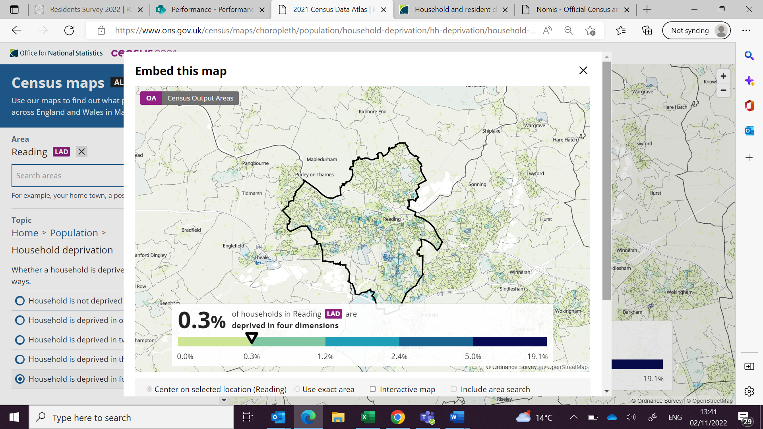

Source: ONS Census 2021

1. Dimensions are: education, employment, health, housing