**CENSUS 2021 - BRIEFING NOTE**

**POPULATION BY AGE, GENDER, NUMBER OF HOUSEHOLDS**

|  |  |  |
| --- | --- | --- |
| **Population by age** | ***2021*** | *2011* |
| **All persons** | **174,200** | **155,700** |
| Aged 4 years and under | **10,200** | 11,900 |
| Aged 5 to 9 years | **10,500** | 8,600 |
| Aged 10 to 14 years | **10,200** | 8,000 |
| Aged 15 to 19 years | **11,000** | 9,800 |
| Aged 20 to 24 years | **14,700** | 14,600 |
| Aged 25 to 29 years | **14,600** | 15,100 |
| Aged 30 to 34 years | **15,600** | 15,200 |
| Aged 35 to 39 years | **14,600** | 12,200 |
| Aged 40 to 44 years | **12,800** | 11,100 |
| Aged 45 to 49 years | **11,300** | 9,900 |
| Aged 50 to 54 years | **10,700** | 8,300 |
| Aged 55 to 59 years | **9,500** | 6,800 |
| Aged 60 to 64 years | **7,400** | 6,400 |
| Aged 65 to 69 years | **5,800** | 4,900 |
| Aged 70 to 74 years | **5,300** | 4,200 |
| Aged 75 to 79 years | **4,000** | 3,400 |
| Aged 80 to 84 years | **2,900** | 2,700 |
| Aged 85+ | **2,900** | 2,600 |

|  |  |  |
| --- | --- | --- |
| **Population by gender** | ***2021*** | *2011* |
| All persons | **174,200** | 155,700 |
| Female | **87,400** | 77,700 |
| Male | **86,800** | 78,000 |
|  |  |  |
| **Population density** (usual residents per square km) | ***2021*** | *2011* |
| All persons | **4,313** | 3,850 |
|  |  |  |
| **Population change** 2011-2021 | 11.9% increase | |
|  |  |  |
| **Number of households** | ***2021*** | *2011* |
| All households with at least one usual resident | **67,700** | 62,900 |

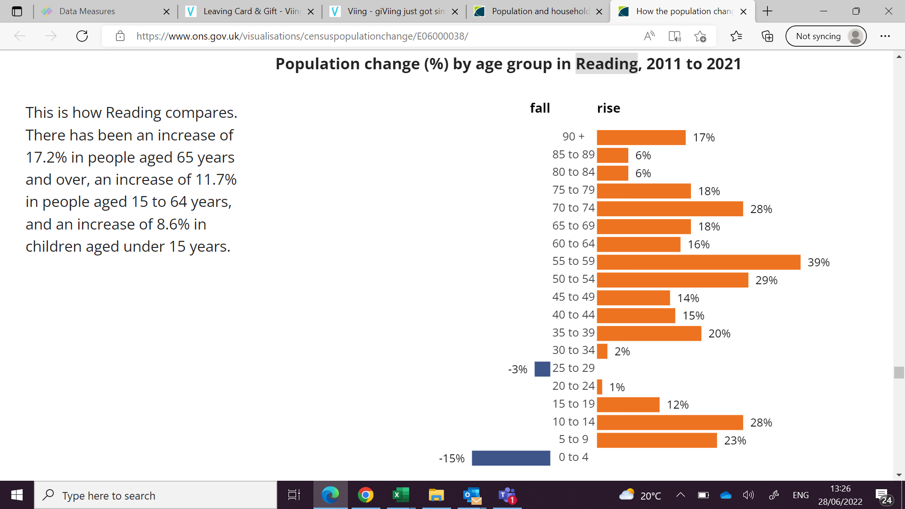

*An interactive report showing population change can be found* [*here.*](https://www.ons.gov.uk/visualisations/censuspopulationchange/E06000038/)

#### *For further information, go to:* [*https://www.ons.gov.uk/census*](https://www.ons.gov.uk/census) *or contact Jill Marston.*