# Building Control Regulations Submission

## The Building Act 1984 | The Building Regulations 2010 as amended 2023 | The Building Safety Act 2022

The application for building control approval with full plans to inform the local authority of building work etc., is restricted to certain building types. This form cannot be used for building control approval applications for higher-risk building work or stage of higher-risk building work or for work to existing higher-risk buildings. Applications for building work to higher-risk buildings can be made [here](https://www.gov.uk/guidance/manage-a-building-control-application-for-a-higher-risk-building?utm_medium=email&utm_campaign=govuk-notifications-topic&utm_source=c6323063-0050-4c04-b498-92296e154abd&utm_content=immediately).

|  |  |  |
| --- | --- | --- |
| **1** |  | **Application Type:**  Full Plans Application: Building Notice: |
|  |  |  |
| **2** |  | **Applicant’s details:** *The person who is submitting the application on the Client’s behalf.*  Name:  Address:  Post Code:  Tel: Email: |
|  |  |  |
| **3** |  | **Client’s details:** *Client is defined as ‘any person for whom a project is carried out’. If the client is the applicant, please state ‘as applicant’.*  Name:  Address:  Post Code:  Tel: Email: |
|  |  |  |
| **4** |  | **Principal Contractor/Sole Contractor details:** *(Where known, if the agent is the principal contractor, then state ‘as applicant details’)*  Name:  Address:  Post Code:  Tel: Email: |
|  |  |  |
| **5** |  | **Principal Designer/Sole or Lead Designer details:** *(Where known, if the agent is the principal designer, then state ‘as applicant details’)*  Name:  Address:  Post Code:  Tel: Email: |
|  |  |  |
| **6** |  | **The location of the site to which the building work relates:**  **Postcode:** |
|  |  |  |
| **7** |  | **Description of works:** *(e.g. Single storey side extension to provide new bathroom. This description will appear on all paperwork including the final certificate)* |
| `: |  |  |
| **8** |  | **Use of the building:** *(Where there are multiple uses, eg. Shop and flats, indicate which storey has which use.)*  Existing: *(if applicable)*  Proposed:  **Will the building be subject to provisions of the Regulatory Reform (Fire Safety) Order 2005?** *(e.g. flats with communal areas, offices, shops, workplaces etc)*  Yes: No: |
|  |  |  |
| **9** |  | **Storeys and Height:** *(Height to be measured from lowest ground level to the floor height of the top storey. The number of storeys in the building is to be determined in accordance with* [*Regulation 6 of the Higher-Risk Buildings (Descriptions and Supplementary Provisions Regulations 2023*](https://www.legislation.gov.uk/uksi/2023/275/regulation/6/made)*.)*  **Existing:**  (m)  Storeys: Top floor height:  **Proposed:**  (m)  Storeys: Top floor height: |
|  |  |  |
| **10** |  | **Planning Information:**  Planning Permission reference:  *If Planning Permission has not yet been obtained, then a copy of the Planning Permission is required within 28 days of permission being granted.*  Have optional requirements in relation to Part M, Access to and use of buildings been imposed by the planning permission?  Yes *(specify)*: No:  Have optional requirements in relation to Part G, Consumption of wholesome water been imposed by the planning permission?  Yes *(specify)*: No: |
|  |  |  |
| **11** |  | **Connectivity Plan:**  *Where the works consist of a new dwelling(s) or a building containing dwellings (flats) then a connectivity plan is required before the application can be processed. This is available from* [*Openreach*](https://www.openreach.com/building-developers-and-projects/fibre-for-developers/registering-your-site#:~:text=Residential%20developments%20with%201%20%2D%2019,Innovation%20and%20Technology%20(DSIT).)*.*  A connectivity plan is required for the works and has been attached: |
|  |  |  |
| **12** |  | **Drainage Provisions:**  **Proposed surface water drainage:**  *(eg. via soakaway)*  **Proposed foul water drainage:**  *(eg. via sewer)*  If the drainage is not being affected by the works please state ‘as existing’  **Requirement H4 of Schedule 1, Building over drains, sewers or disposal mains:**  Where paragraph [H4 of Schedule 1](https://www.legislation.gov.uk/uksi/2010/2214/schedule/1) imposes a requirement, provide details of the precautions to be taken when building over the drain, sewer or disposal main to comply with the requirements of that paragraph. |
|  |  |  |
| **13** |  | **Commencement:**  Select the relevant option for commence based on the works:  **New Building or Extension**: *When the foundations (including a basement) and ground floor structure are completed.*  **Material Alteration, Material Change of Use or any other works on an existing building**: *When 15% of that work has been completed, please specify below.*  **Complex Buildings only**: *When the foundations supporting the building and the structure of the lowest floor level have been completed (but not other buildings or structures supported by those foundations)*  Description of proposed stage 15% of works commenced:  **Approximate date of commencement:**  *If the proposed works are not sufficiently progressed to be considered commenced within 3 years of the application being made, then the approval is considered lapsed, and the application and any approvals will cease to apply.* |
|  |  |  |
| **14** |  | **Further Requirements:**  Do you consent to the application for building control approval with full plans being granted with requirements*.  Yes: No:  *\*Requirements are modifications that the local authority may specify must be made in the full plans, or further plans as the authority may specify must be provided before work to which those plans relate starts.* |
|  |  |  |
| **15** |  | **Fees and Charges:**  Name of person responsible for paying fees:  Telephone number:  Email address: |
|  |  |  |
| **16** |  | **Declaration:**  This application for building control approval with full plans is in relation to the building work etc., as described above. It is submitted in accordance with [Regulation 12(2)(b)](https://www.legislation.gov.uk/uksi/2010/2214/regulation/12) and is accompanied by the appropriate charge.  **I understand that further applicable charges (such as inspection fees) may become payable by the building owner following the first inspection undertaken by the local authority.**  I/we apply for building control approval with full plans as described on this form and as detailed on any supplementary documents.  **Applicant signature:** Date:  I, the client, confirm I agree to the application being made and that the information contained in the application is correct.  **Client signature:** Date: |

Additional information may also be required to accompany your application for building control approval with full plans, depending upon the work proposed.

If you do not complete any part of the form (where applicable) this may delay the validation of your application.

# Application Form Guide

This guide covers what sections of the application form must be completed and what answers are required. All the information we request in the application form is required under The Building Regulations 2010 (except payment information); the application cannot be validated without this information.

## Sections Required:

1, 2, 3, 6, 7, 8, 9, 12, 13, 14, 15, 16

These sections must always be completed in full.

Indicates areas that need information.

Other sections may only apply to certain works (such as new building), the criteria for them being required will be including in the information below the section.

## Information Required:



**Section 1:** One box must be ticked, we cannot accept it if both or none of the boxes are selected.

*We will accept people deleting or crossing out the irrelevant box.*



**Section 2:** They **must** include information in all sections, including **telephone number** and **email**.

*An email address must be provided for correspondence.*

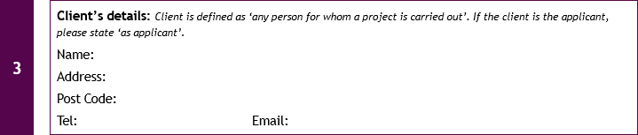

**Section 3:** We must be provided with client details, this includes name, address, telephone number and email address. If any of these are missing they must be requested.

*If the client is the applicant, they must state this eg. “Same as applicant” or “Same as above”.*

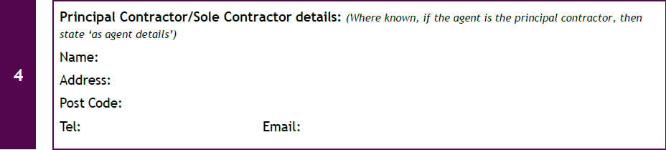

**Section 4:** This is not required at time of application but **must** be in place before an inspection can be carried out. If this section is filled in we will require all the contact information including **telephone number** and **email address**. *We will accept ‘same as applicant’*.

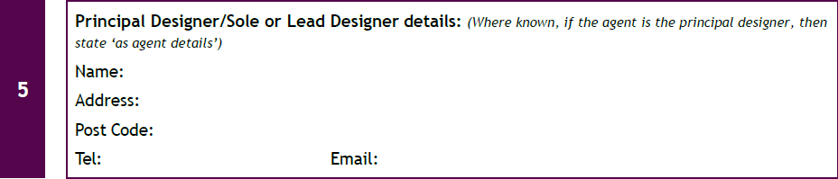

**Section 5:** Same as section 4, all information must be provided before inspection takes place.

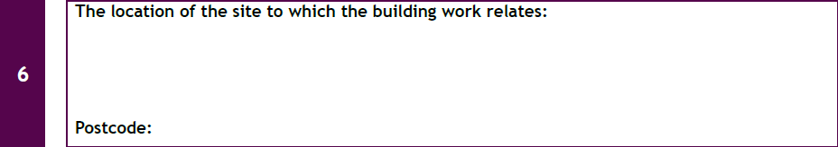

**Section 6:** This must include at least the first line of the address and post code. If it is a new building, then ‘land adjacent’ or similar is acceptable.

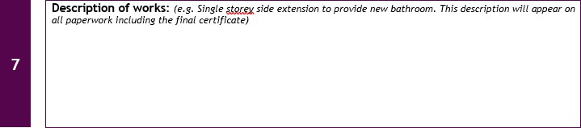

**Section 7:** The description of works will appear on all letters and documents and should be restricted to terms such as “single storey side extension”, “loft conversion”, etc and cannot be a breakdown of technical aspect of works carried out or include non-building control related information. Such information can be provided in a supplementary letter/Email.

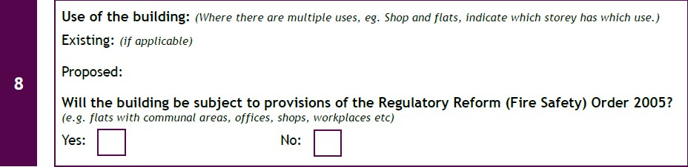

**Section 8:** The use of the building applies to the **whole building** and not just the area in which the works are being carried out. Appropriate descriptions include: Dwelling, domestic dwelling, private home, HMO, Shop, Warehouse, Offices, etc. ‘Extension’ or ‘Kitchen’ do not identify the use of the building and would be considered unacceptable. **Both the existing and proposed must be completed** unless it is a new building, in which case existing is not required.

One box for the regulatory reform order must be selected. **If ‘Yes’ is selected the application must be a full plans**, if the applicant has selected building notice then they must be informed we cannot accept a building notice for works subject to the Regulatory Reform (Fire Safety) Order 2005.

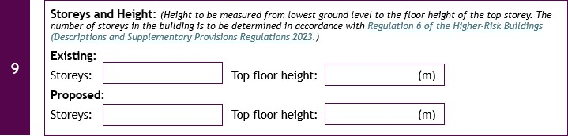

**Section 9:** The storeys is the maximum number of floors in the whole building, not just the area in which the works are being carried out. The height is measured from the lowest external ground level to the finished floor level of the top floor, **not to the roof or eaves.** If the works do not change the overall floor height/storeys, then the existing and proposed will be the same.

If someone is doing a single storey extension on a two storey house the floor height and storeys will not change. In a single storey dwelling an average floor height will be between 0 - 1m, for a two-storey dwelling it will be between 2.5 – 3.5m and in a three storey dwelling or house with loft conversion it will be between 5 - 6m.

The diagram below shows how to measure the height of most types of domestic dwelling:

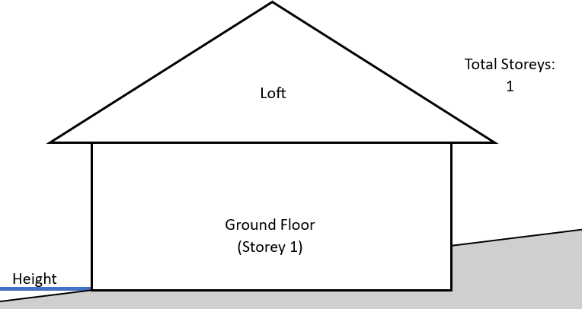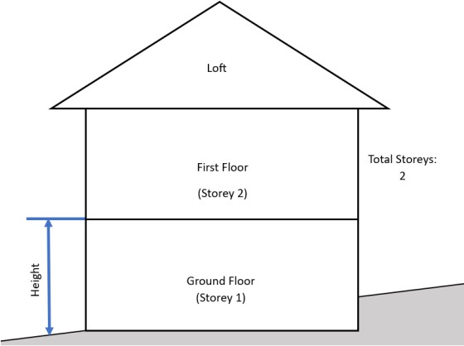

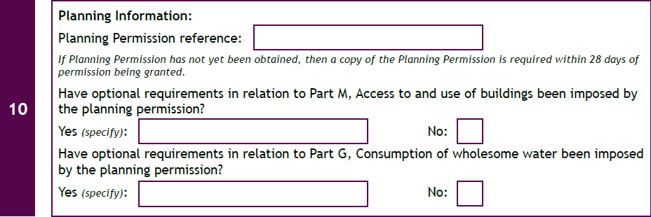

**Section 10:** Planning Permission is not always required. You would expect to see planning permission for new buildings, large extensions, two storey extensions or works to the front of the property eg. Porch.

The optional requirements apply only to new dwellings.

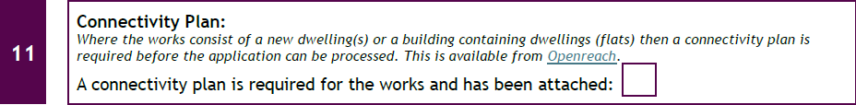

**Section 11:** Connectivity plans are only required for new dwellings/flats. It will be attached as a separate document.

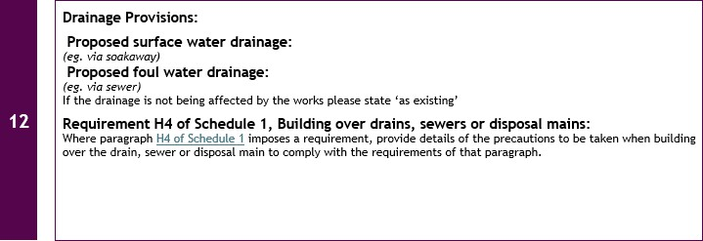

**Section 12:** This section must be completed, if the works will not affect the drainage then ‘as existing’ or ‘no change’ are acceptable answers.

Other acceptable answers include: ‘To existing soakaway’, ‘To new soakaway’, ‘To existing sewer’ or ‘New sewer connection’.

The bottom section is only required where it is known that the works will be within 3m of a Thames Water Asset (sewer). The description should either refer to specific drawings or be a written

description of how the requirements are going to be met.

*If someone identifies they are building near/over a sewer then the application should be a full plans application. If a sewer has been identified but a building notice submitted, the application should be a full plans application and all drawings/details/specification including the sewer build-over or build near submitted.*

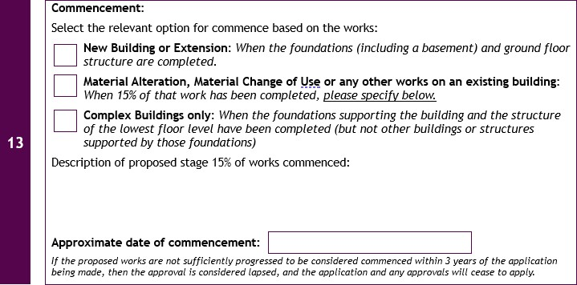

**Section 13:** One of the boxes **must** be selected. If the applicant selects the second box they must complete the 15% of works description.

Examples include: ‘Removal of existing wall and installation of temporary support’ for a wall or

chimney removal, for a loft conversion it could be ‘installation of dormer framing’, for replacement windows this could be ‘removal of old windows’. If you are not sure check with Principal Designer and/or Principal Contractor.

The date of commencement is the approximate date at which the works will reach the point either next to the box selected or the 15% description.

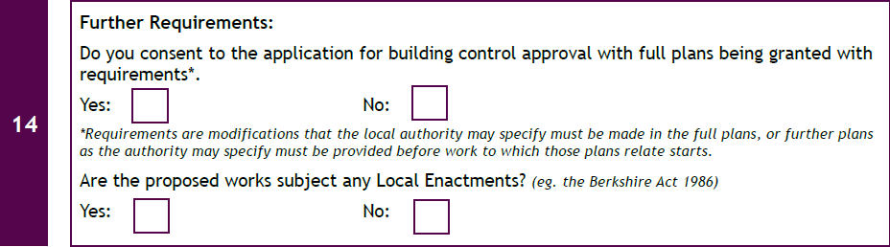

**Section 14:** The first set of boxes only need to be completed for Full Plans applications. If the box is ticked on a building notice this can be ignored as the plans are not checked.



**Section 15:** This should be completed and at least a name and telephone number provided, in case of problems with collecting payment.

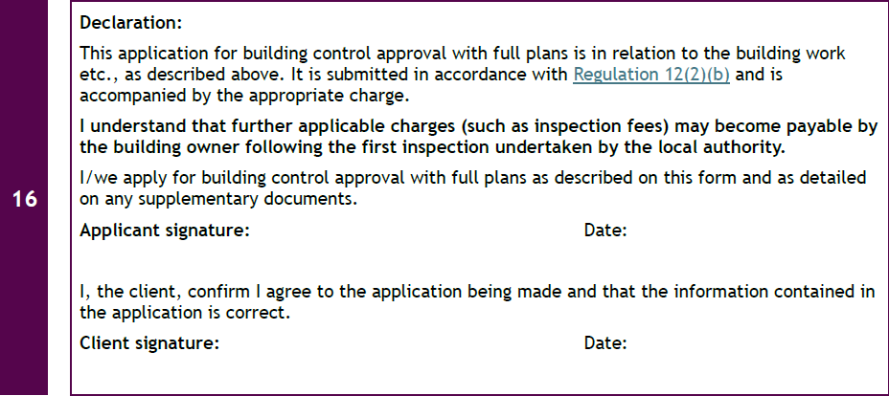

**Section 16:** The **Client** must always sign their own signature. The application cannot be signed on their behalf by the agent.

Useful links:

[Roles of Dutyholders - GOV.UK](https://www.gov.uk/guidance/design-and-building-work-meeting-building-requirements)

[Foundation Depth Calculator | Building near trees | LABC Warranty](https://www.labcwarranty.co.uk/foundation-calculator)

[Building control - Reading Borough Council](https://www.reading.gov.uk/planning-and-building-control/building-control/)

[Planning Portal](https://www.planningportal.co.uk/)