**Rainwater Soakaways Design for areas of 25m2 or less.**

Soakaways are a traditional way of disposing of surface water from the buildings remote from a suitable public sewer or watercourse. A soakaway must have capacity to store immediate run-off from roofs and hard surfaces and the water must then be able to disperse into the surrounding soil quickly enough for the soakaway to be able to cope with the next storm.

Soakaways are probably the most common form of surface water disposal and are usually suitable for areas less than 100m2. Soakaways are generally formed from square or circular pits, filled with rubble or lined with dry jointed masonry or perforated concrete ring units. Soakaways serving larger areas are generally lined pits, trench type soakaways or constructed from specialist proprietary units. It should be expected that a domestic rubble filled soakaway may need to be renewed about every ten years.

For small soakaways serving 25m2 or less, a design rainfall of 10mm in 5 minutes is quoted in the Building Regulation Approved Document H as being an appropriate worst case.

For soakaways serving areas greater than 25m2 reference should be made to BS EN 752-4, or BRE Digest 365 Soakaway design. BRE Digest 365 is the most commonly used document.

The Building Regulations dictate an order of priority for the selection of surface water from buildings and these are:

1. an adequate soakaway or some other adequate filtration system, or where that is not reasonably practical,

2. a watercourse, or where that is not reasonably practical,

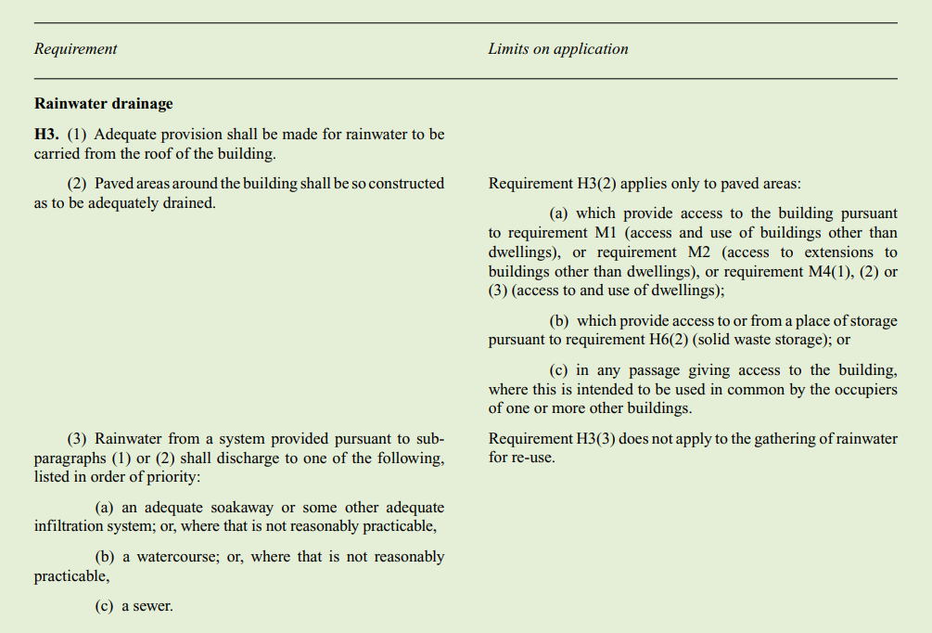3. an appropriate sewer

**A soakaway must always be the first choice but must not be used:**

Within 5m of a building or road, 2.5m of a boundary or in an area of unstable land in ground where the water table reaches the bottom of the soakaway at any time of the year. near any drainage field, drainage mound or other soakaway so that the overall soakage capacity of the ground is exceeded and the effectiveness of any drainage field impaired; where the presence of any contamination in the runoff could result in pollution of groundwater source or resource.

Percolation tests should be carried out to determine the capacity of the soil

**Percolation Test Method for Rain Water Disposal**

1. A hole 300mm square should be excavated to a depth 300mm below the proposed invert level of the incoming pipe. Where deep drains are necessary, the hole should conform to this shape at the bottom, but may be enlarged above the 300mm level to enable safe excavation to be carried out. Where very deep excavations are necessary, you should seek specialist advice.
2. Fill the 300mm square section of the hole to a depth of at least 300mm with water and allow it to seep away overnight.
3. Next day, refill the 300mm square section of the hole with water to a depth of at least 300mm and observe the time, in seconds, for the water to seep away from 75% full to 25% full level (i.e. a depth of 150mm). Divide this time by 150mm. The answer gives the average time in seconds (Vp) required for the water to drop 1mm. For example 60mins divided by 150mm = 24 seconds (Vp = 24 seconds)
4. The test should preferably be carried out at least three times with at least two trial holes. The average figure from the tests should be taken. The test should not be carried out during abnormal weather conditions such as heavy rain, severe frost or drought.

Where the test is carried out as described above, the soil infiltration rate (f) is related to the value (Vp) derived from the test by the equation:

**Formula to calculate the Soil Filtration rate.**

f =10-3

2Vp

The storage volume should then be calculated so that, over the duration the storm, the storage volume is sufficient to contain the difference between the inflow volume and the outflow volume. The inflow volume is calculated from the rainfall depth and the area drained. The outflow volume (O) is calculated from the equation:

**O = as50 x f x D**

Where as50 is the area of the side of the storage volume when filled to 50% of its effective depth (for example (1m2/2) x 4 = 2m2) and (D) is the duration of the storm in minutes (for example 5 minutes).

**Example – Drained area = 25m2**

Incoming water is 25m2 area x 10mm of rainfall = 0.25m3 of water to be disposed of.

Outflow volume is: O = as50 x f x D **therefore** O = 2x 0.0002 x 5 **and thus** O = 0.002m3

Therefore required capacity is 0.25m3 - 0.002m3 = 0.248m3. Which means that a traditional rubble filled soakaway measuring 1m3 below the inlet pipe and with, say, 20% void, ie 0.2m3 storage capacity, will not be adequate and the soakaway volume should be increased to 1.24m3 capacity.

**Important**

**This information is mainly based on the advice contained in section H2 of Building Regulation Approved Document H 'Drainage and Waste Disposal' 2002 edition. This guidance does not substitute for the Approved Document, or BRE Digest 365, which should be referred to for full information about the sizing and design of soakaways.**

Please see that this document was originally published by Copeland Borough Council on

07/06/2013.